IDS 462 STATISTICAL SOFTWARE IN BUSINESS
PROJECT 2 – Statistical Analysis on the Ames Home Sales Data Set
TEAM 12
Balachandhar Chekka Narayanasame
Harish Visweswaraiya
Contents

Project Objective 3
Data Description 3
Q1 Distinguishing variables and defining macro variables 3
Variable Exclusion 3
Variables and their types 3
Q2 Exploratory Data Analysis - Proc Univariate and Proc Freq 4
Q3 T-test to evaluate the mean of sale price 4
Q4 T-test to evaluate the mean of SalePrice for homes with Masonary Veneer 5
Q5 Scatter Plots and Comparative Box Plots 5
Q6 - Analysis of variance - SalePrice vs Heating_QC 5
Q7 - Comparison information about the mean sale prices of the different heating system quality ratings 5
Q8 – Relationship between SalePrice and other continuous predictor variables 6
Q9 – Simple Linear Regression 6
Q10 - Two Way Anova - SalePrice with Heating_QC and Season_sold(GLM) 6
Q11 – Two Way Anova - SalePrice with Heating_QC and Season_sold(PLM) 7
Q12 – Regression Model 7
Appendix 8
Question 1 8
Code Snippet 8
Question 2 8
Code Snippet 8
Output 9
Question 3 31
Code Snippet 31
Output 31
Question 4 33
Code Snippet 33
Output 34
Question 5 36
Code Snippet 36
Output 40
Question 6 67
Code Snippet 67
Output 68
Question 7 72
Code Snippet 72
Output 72
Question 8 74
Code Snippet 74
Output 75
Question 9 75
Code Snippet 75
Output 76
Question 10 84
Code Snippet 84
Output 85
Question 11 89
Code Snippet 89
Output 89
Question 12 99
Code Snippet 99
Output 100
References 104

Project Objective
- The objective is to perform a statistical analysis on the Ames Home Sales data set which contains information about the sale of individual residential property in Ames, Iowa, from 2006 to 2010.
- The statistical findings for each problem are listed in the report.

Data Description
- The data set contains information about the sale of individual residential property in Ames, Iowa from 2006 to 2010.
- The data set considered for analysis contains 31 variables and 500 observations in total.

Q1 Distinguishing variables and defining macro variables
- In order to analyze the data statistically, the first step is to distinguish the 31 variables into continuous and categorical variables.
- The macro variables &categorical and &interval are defined to store all the categorical and continuous variables. These macro variables act as global variables and as the project involves the statistical analysis of these variables, the code redundancy could be avoided.

Variable Exclusion
- The below variables and the reasons for exclusion are listed below.
- PID: As it is a unique identification variable, it is not considered for further statistical analysis.
- Year_sold and Year_built: As Age_sold variable is the difference between Year_sold and Year_built variables, the variables Year_sold and Year_built are not considered for further analysis.

Variables and their types
- The other 28 variables and their types are listed below
S NO | VARIABLE NAME | VARIABLE TYPE
1 | House_Style | Categorical
2 | Overall_Qual | Categorical
3 | Overall_Cond | Categorical
4 | Heating_QC | Categorical
5 | Central_Air | Categorical
6 | Bedroom_AbvGr | Categorical
7 | Fireplaces | Categorical
8 | Mo_Sold | Categorical
9 | Full_Bathroom | Categorical
10 | Half_Bathroom | Categorical
11 | Total_Bathroom | Categorical
12 | Season_Sold | Categorical
13 | Garage_Type_2 | Categorical
14 | Foundation_2 | Categorical
15 | Masonry_Veneer | Categorical
16 | Lot_Shape_2 | Categorical
17 | House_Style2 | Categorical
18 | Overall_Qual2 | Categorical
19 | Overall_Cond2 | Categorical
20 | Bonus | Categorical
21 | Lot_Area | Interval
22 | Gr_Liv_Area | Interval
23 | Garage_Area | Interval
24 | SalePrice | Interval
25 | Basement_Area | Interval
26 | Deck_Porch_Area | Interval
27 | Age_Sold | Interval
28 | Log_Price | Interval

The code snippets and output are provided in the Appendix-q1 Section.

Q2 Exploratory Data Analysis - Proc Univariate and Proc Freq
- Proc Univariate statement is used to perform exploratory data analysis, provide descriptive statistics and generate distribution and probability plots for the numerical (interval) variables.
- The below table provides the descriptive statistics for the numerical variables.
Variables | Mean | Median | Mode | Std dev | Range | Inter Quartile Range
Lot_Area | 8549.604 | 8529.500 | 7200 | 3655 | 40300 | 3839
Gr_Liv_Area | 1147.068 | 1152 | 864 | 231.737 | 1166 | 390
Garage_Area | 393.254 | 408 | 0 | 186.478 | 1488 | 219
SalePrice | 140504.1 | 138750 | 130000 | 38217 | 250700 | 43750
Basement_Area | 912.63 | 912 | 864 | 323.244 | 1645 | 402.5
Deck_Porch_Area | 121.423 | 92.5 | 0 | 130.92 | 804 | 192
Age_Sold | 44.046 | 43 | 1 | 27.03 | 117 | 31
Log_Price | 11.814 | 11.84 | 11.775 | 0.2873 | 1.9986 | 0.31712

- Proc Freq statement is used to perform exploratory data analysis, compute frequency distribution and generate bar charts for the categorical variables.
The code snippets and output are provided in the Appendix-q2 Section .

Q3 T-test to evaluate the mean of sale price
- Null hypothesis H0: The mean of the SalePrice variable in the data set is $135,000.
- Alternate Hypothesis Ha: The mean of the SalePrice variable in the data set is not equal to $135,000.
- After performing the T test, the determined p value is 0.0014 which is less than the significance value of 0.05.
- Therefore we reject the null hypothesis. Therefore, the mean of the SalePrice variable in the data set is not equal to $135,000.
The code snippets and output are provided in the Appendix-q3 Section.

Q4 T-test to evaluate the mean of SalePrice for homes with or without Masonary Veneer
- Null hypothesis H0: The mean of the SalePrice variable in the data set is same for homes with or without masonary veneer.
- Alternate Hypothesis Ha: The mean of the SalePrice variable in the data set is not the same for homes with or without masonary veneer.
- After performing the T test, the determined p value is 0.7277 which is greater than the significance value of 0.05.
- Therefore we fail to reject the null hypothesis. Therefore, the mean of the SalePrice variable in the data set is same for homes with or without masonary veneer.
The code snippets and output are provided in the Appendix-q4 Section.

Q5 Scatter Plots and Comparative Box Plots
- PROC CORR statement is used to generate scatter plot which illustrates the relationships between continuous predictors and SalePrice.
- PROC SGPLOT statement is used to generate comparative plot which illustrates the relationships between categorical predictors and SalePrice. The comparative box plots are given below.
The code snippets and output are provided in the Appendix-q5 Section.

Q6 - Analysis of variance - SalePrice vs Heating_QC
- PROC GLM statement is used to perform one way ANOVA test with Heating_QC as the predictor variable and SalePrice as the response variable.
- Heating_QC has four categories for the given data set – Ex, Fa, Gd, Ta
- From ANOVA test, the determined F-Value is 35.52. This indicates that there is high variability between different group means when compared to variance within the groups.
- Levene’s test of homogeneity of variances is used to identify squared deviations from group means in Heating_QC variable. This test is performed using default type, square. F-Value of 6.07 is obtained from Levene test.
The code snippets and output are provided in the Appendix-q6 Section.

Q7 - Comparison information about the mean sale prices of the different heating system quality ratings
- PROC GLM statement with LSMEANS option is used to produce comparison information about
the mean sale prices of the different heating system quality ratings.
- LSMEANS is another method of post-hoc ANOVA to compute group means.
The code snippets and output are provided in the Appendix-q7 Section.

Q8 – Relationship between SalePrice and other continuous predictor variables
- PROC CORR statement is used to examine the relationships between SalePrice and the continuous predictor variables in the data set.
- The highest correlation coefficient is observed for Age_sold variable with negative correlation strength of 65.36%.
- Though the highest correlation is observed for variable log_price, it is nothing but the natural logarithm applied on the response variable. Hence, it has been excluded from the analysis.
The code snippets and output are provided in the Appendix-q8 Section.

Q9 –Linear Regression Analysis
- Multiple regression analysis is performed with SalePrice as the response variable and the other continuous predictor variable.

Step | Effect  Entered | Number  Effects In | F Value | Pr > F
0 | Intercept | 1 | 0.00 | 1.0000
1 | Age_Sold | 2 | 371.54 | <.0001
2 | Gr_Liv_Area | 3 | 233.38 | <.0001
3 | Basement_Area | 4 | 158.51 | <.0001
4 | Garage_Area | 5 | 56.92 | <.0001
5 | Deck_Porch_Area | 6 | 43.10 | <.0001
6 | Lot_Area | 7 | 23.12 | <.0001

- The equation for predicting the SalesPrice with all six predictor variables step wise regression is given below
SalePrice= 50238 + 1.158*Lot_Area + 50.086* Gr_Liv_Area + 34.1889*
Garage_Area+ 30.4069*Basement_Area + 42.426*Deck_Porch_Area
– 532.07 * Age_Sold
- From the above table, Age_sold is the most significant predictor at 95% confidence level with a F-value of 371.54.
- The equation for predicting the SalesPrice with the most significant predictor variables with forward regression is given below
SalePrice=181209 – 924.144*Age_Sold
The code snippets and output are provided in the Appendix-q9 Section.

Q10 - Two Way Anova - SalePrice with Heating_QC and Season_sold (GLM)
- A two-way ANOVA is performed with SalePrice with Heating_QC and Season_Sold as predictor variables.
- PROC GLM statement is used to discover the effects of both Season_Sold and Heating_QC.
- The individual group means of each categorical variable, Season_Sold and Heating_QC is determined.
- Two way ANOVA results provide us an output with degrees of freedom (df) as 6 and F-Value of 17.9.
- We observed that Heating_QC has high F-Value of 35.39 and Season_Sold has low F-Value of 0.4.
- We infer that Season_Sold has high variability within the group when compared to variance between the groups.
The code snippets and output are provided in the Appendix-q10 Section.

Q11 – Two Way Anova - SalePrice with Heating_QC & Season_sold (PLM)
- A two-way ANOVA is performed with SalePrice with Heating_QC and Season_Sold as predictor variables.
- PROM GLM is used to store the interaction effect of Season_Sold and Heating_QC with respect to response variable SalePrice.
- Then PROC PLM statement is used to discover the effects of both Season_Sold and Heating_QC and also includes the interaction between the two explanatory variables.
The code snippets and output are provided in the Appendix-q11 Section.

Q12 – Multi Regression Analysis
- A multiple regression analysis is performed with SalePrice as the response variable and Lot_Area and Basement_Area as predictor variables.
- The parameter estimates are the values for the regression equation for predicting the dependent variable from the independent variable.
  - Lot_Area - For every unit increase in Lot_Area, a 1.613 unit increase in SalePrice is predicted.
  - Basement_Area - For every unit increase in Basement_Area, a 68.56 unit increase in SalePrice is predicted.
- Mallows' Cp is used to choose between multiple regression models and strike an important balance with the number of predictors in the model by comparing the precision and bias of the full model to models with a subset of the predictors.
- With a low Cp value of 3.0, the model with Lot_Area is more precise with high variance and less bias.
The code snippets and output are provided in the Appendix-q12 Section.

Appendix
The following section contains the SAS code and the respective outputs for all the questions in the project.
/* The following code defines library*/
libname Project2 '/folders/myfolders/Project2';

Question 1

Code Snippet
/* The following code defines macro variable for categorical variables*/
%Let categorical=House_Style Overall_Qual Overall_Cond Heating_QC Central_Air Bedroom_AbvGr Fireplaces Mo_Sold Full_Bathroom Half_Bathroom Total_Bathroom Season_Sold Garage_Type_2 Foundation_2 Masonry_Veneer Lot_Shape_2 House_Style2 Overall_Qual2 Overall_Cond2 Bonus;

/* The following code defines macro variable for numerical variables*/
%Let interval=Lot_Area Gr_Liv_Area Garage_Area SalePrice Basement_Area Deck_Porch_Area Age_Sold Log_Price;

Question 2

Code Snippet
/* PROC UNIVARIATE is used to generate plots and descriptive statistics for continuous variables */

proc univariate data=Project2.team12 plot;

var &interval;

run;

/* PROC FREQ is used to generate plots and tables for categorical variables */
proc freq data=Project2.team12;
tables &categorical/plots=freqplot(type=BARCHART);
run;

Output
The distribution and probability plots for the numerical variables are found below

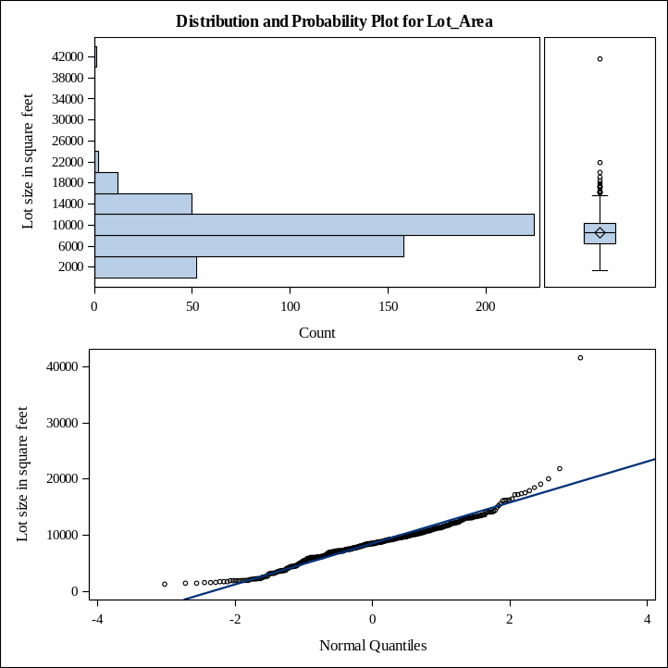
Figure 1: Distribution and Probability plot for Lots_area

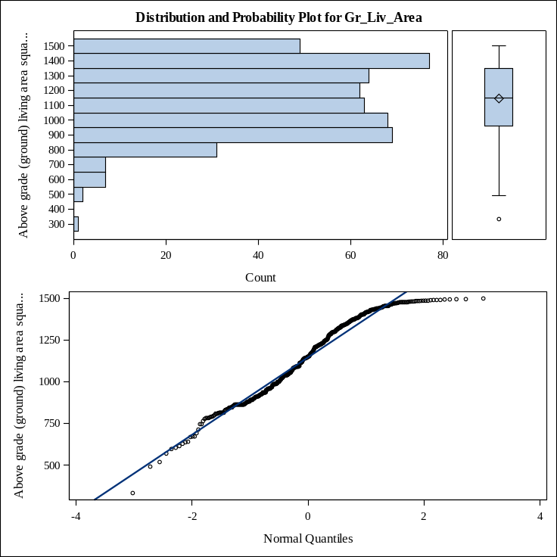
Figure 2: Distribution and Probability plot for Gr_liv_area

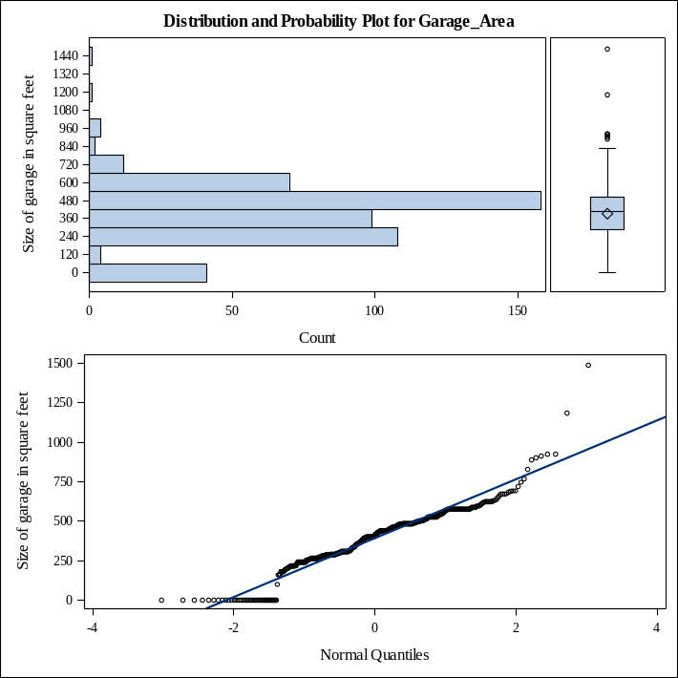
Figure 3: Distribution and Probability plot for Garage_Area

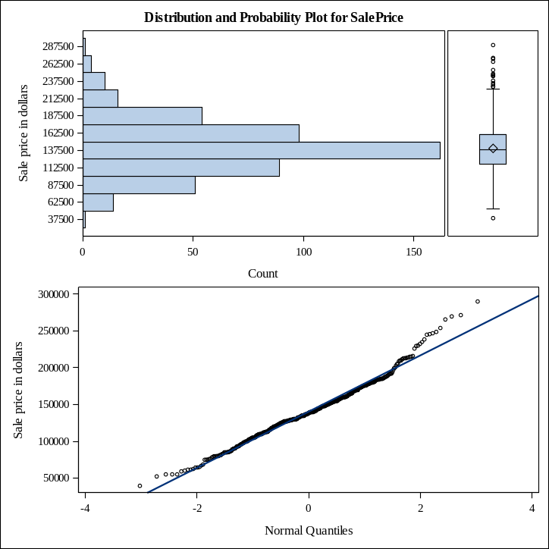
Figure 4: Distribution and Probability plot for Safe_Price

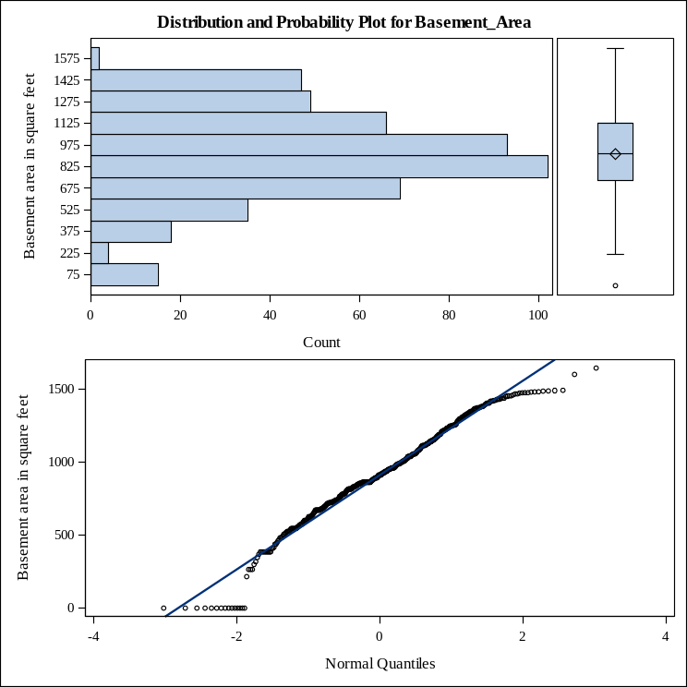
Figure 5: Distribution and Probability plot for Basement_Area
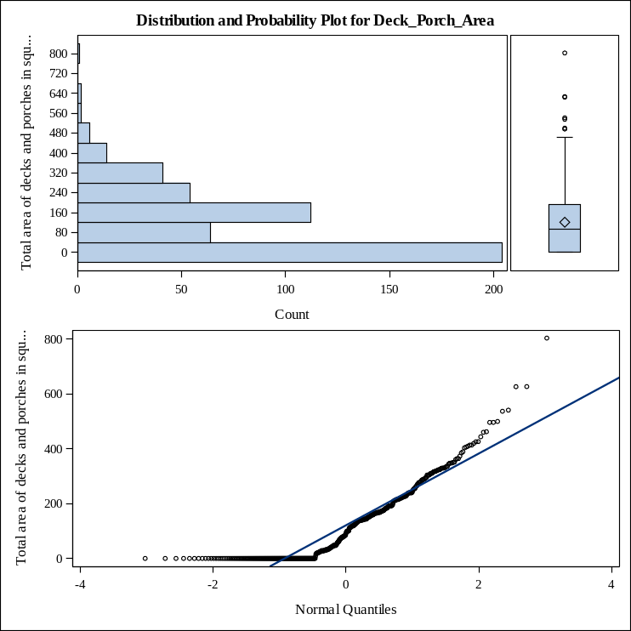
Figure 6: Distribution and Probability plot for Dark_Porch_Ares

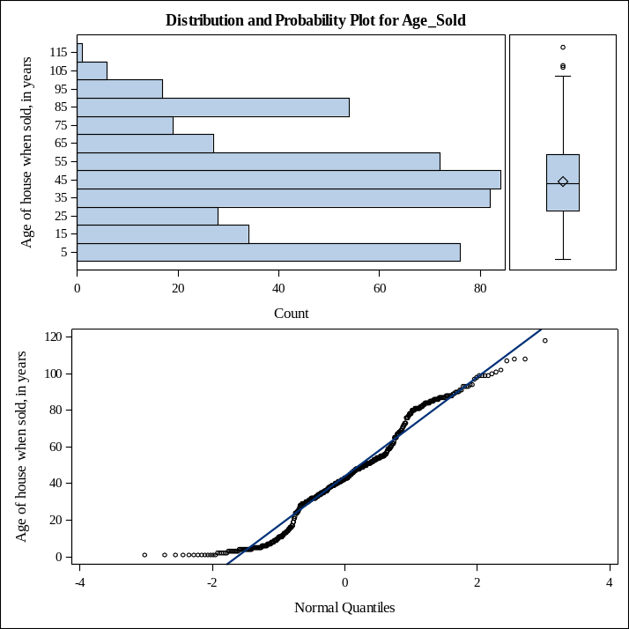
Figure 7: Distribution and Probability plot for Age_sold
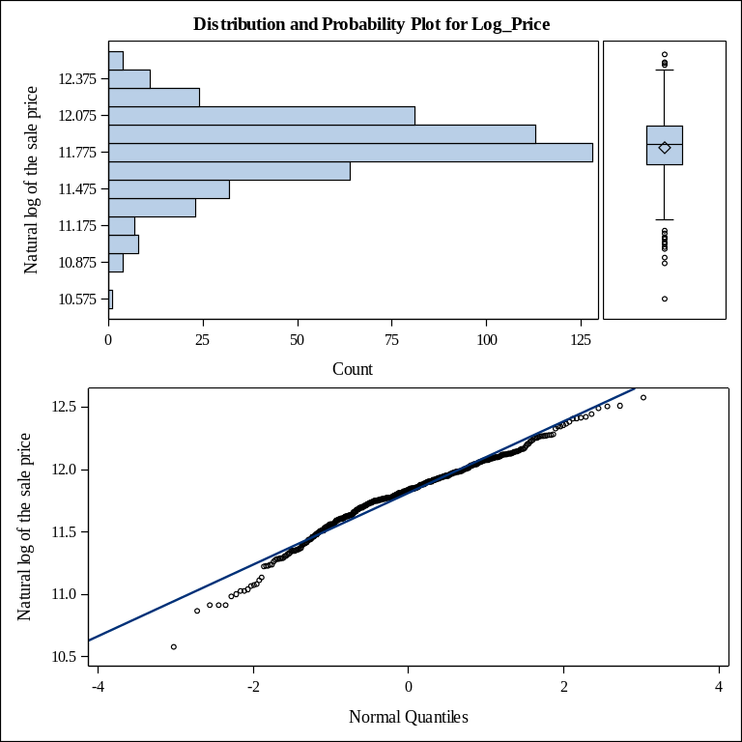
Figure 8: Distribution and Probability plot for Age_sold
- The frequency distribution and the bar charts for the categorical variables are listed below

- Style of dwelling
House_Style | Frequency | Percent | Cumulative  Frequency | Cumulative  Percent
1.5Fin | 53 | 10.60 | 53 | 10.60
1.5Unf | 10 | 2.00 | 63 | 12.60
1Story | 313 | 62.60 | 376 | 75.20
2Story | 63 | 12.60 | 439 | 87.80
SFoyer | 22 | 4.40 | 461 | 92.20
SLvl | 39 | 7.80 | 500 | 100.00

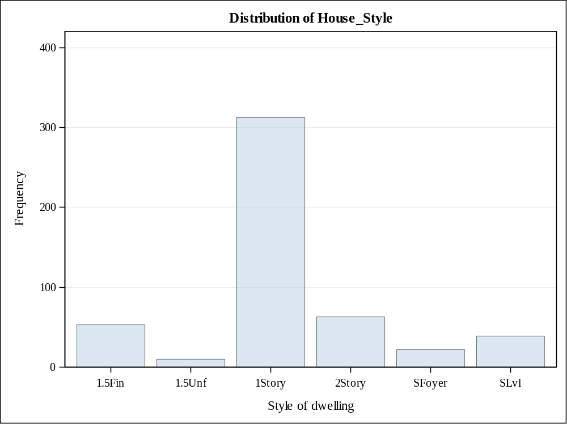

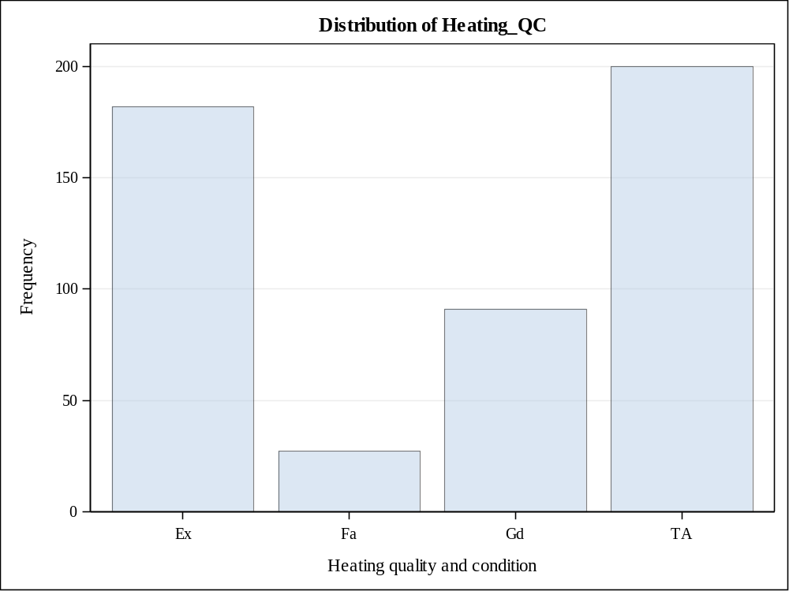

Presence of central air conditioning
Central_Air | Frequency | Percent | Cumulative  Frequency | Cumulative  Percent
N | 41 | 8.20 | 41 | 8.20
Y | 459 | 91.80 | 500 | 100.00

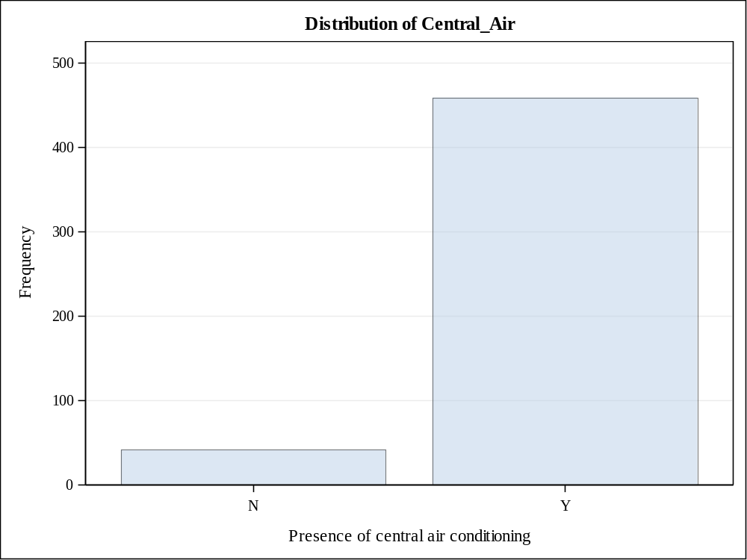

Bedrooms above grade
Bedroom_AbvGr | Frequency | Percent | Cumulative  Frequency | Cumulative  Percent
0 | 1 | 0.20 | 1 | 0.20
1 | 23 | 4.60 | 24 | 4.80
2 | 172 | 34.40 | 196 | 39.20
3 | 291 | 58.20 | 487 | 97.40
4 | 12 | 2.40 | 499 | 99.80
5 | 1 | 0.20 | 500 | 100.00

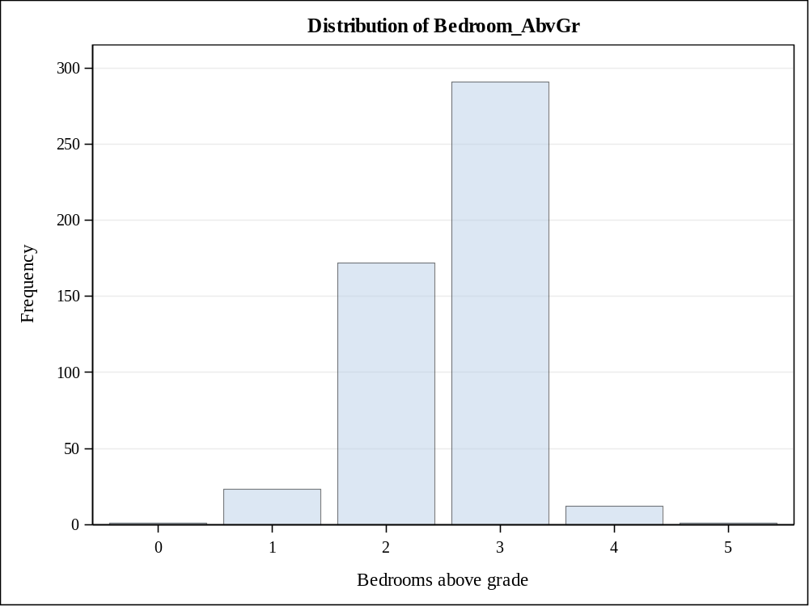

Number of fireplaces
Fireplaces | Frequency | Percent | Cumulative  Frequency | Cumulative  Percent
0 | 323 | 64.60 | 323 | 64.60
1 | 164 | 32.80 | 487 | 97.40
2 | 13 | 2.60 | 500 | 100.00

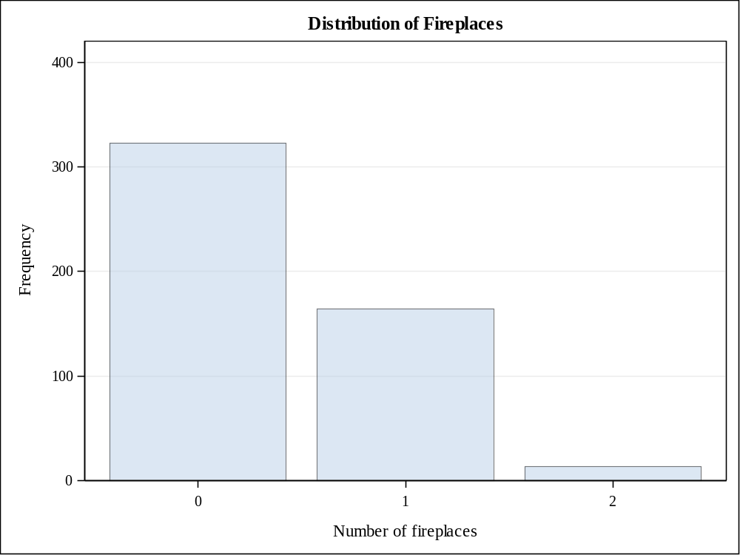

Month Sold (MM)
Mo_Sold | Frequency | Percent | Cumulative  Frequency | Cumulative  Percent
1 | 16 | 3.20 | 16 | 3.20
2 | 23 | 4.60 | 39 | 7.80
3 | 44 | 8.80 | 83 | 16.60
4 | 56 | 11.20 | 139 | 27.80
5 | 84 | 16.80 | 223 | 44.60
6 | 97 | 19.40 | 320 | 64.00
7 | 60 | 12.00 | 380 | 76.00
8 | 33 | 6.60 | 413 | 82.60
9 | 25 | 5.00 | 438 | 87.60
10 | 22 | 4.40 | 460 | 92.00
11 | 26 | 5.20 | 486 | 97.20
12 | 14 | 2.80 | 500 | 100.00

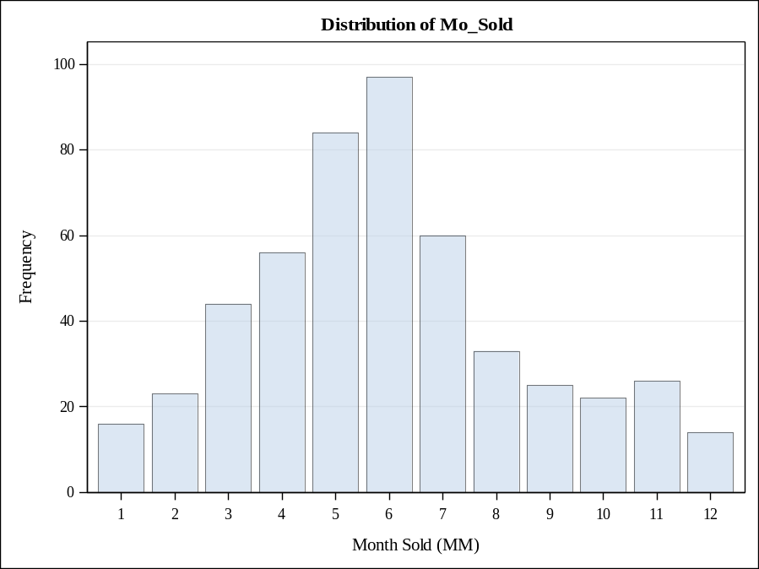

Number of full bathrooms
Full_Bathroom | Frequency | Percent | Cumulative  Frequency | Cumulative  Percent
1 | 191 | 38.20 | 191 | 38.20
2 | 259 | 51.80 | 450 | 90.00
3 | 49 | 9.80 | 499 | 99.80
4 | 1 | 0.20 | 500 | 100.00

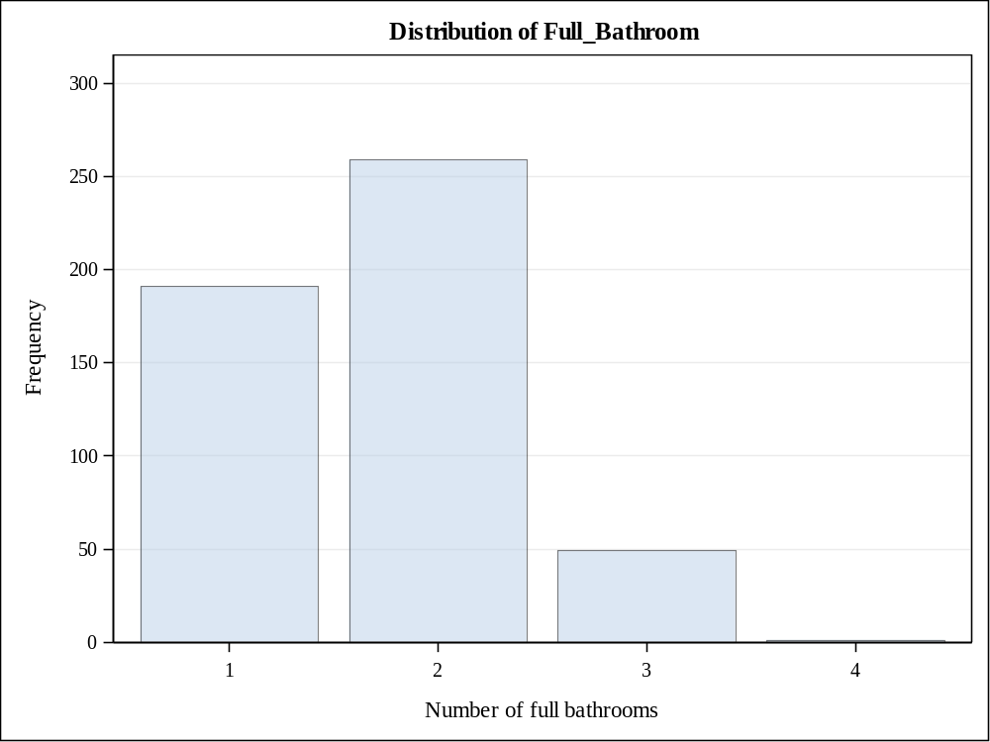

Number of half bathrooms
Half_Bathroom | Frequency | Percent | Cumulative  Frequency | Cumulative  Percent
0 | 355 | 71.00 | 355 | 71.00
1 | 141 | 28.20 | 496 | 99.20
2 | 4 | 0.80 | 500 | 100.00

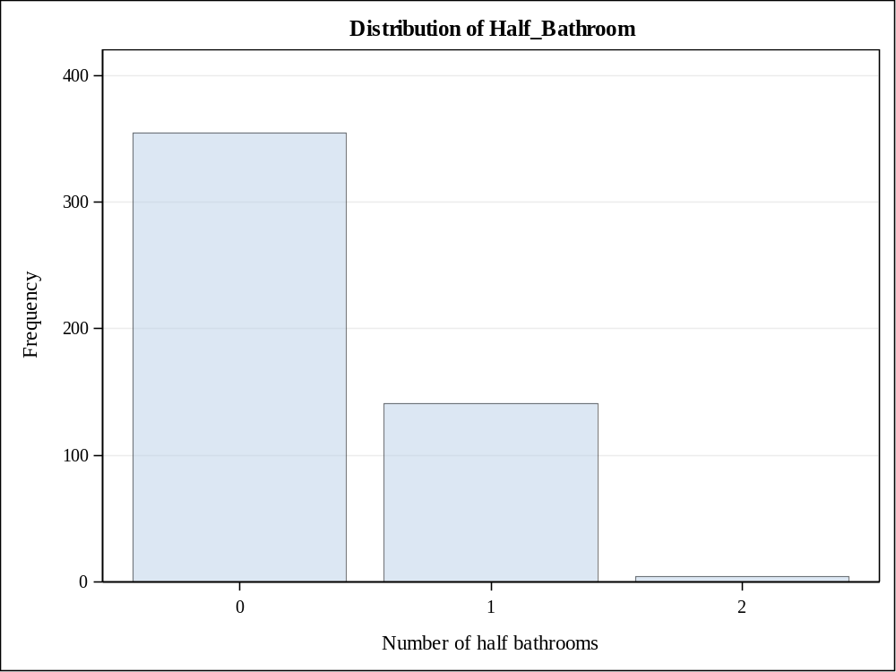

Total number of bathrooms (half bathrooms counted 10%)
Total_Bathroom | Frequency | Percent | Cumulative  Frequency | Cumulative  Percent
1 | 120 | 24.00 | 120 | 24.00
1.1 | 68 | 13.60 | 188 | 37.60
1.2 | 3 | 0.60 | 191 | 38.20
2 | 195 | 39.00 | 386 | 77.20
2.1 | 63 | 12.60 | 449 | 89.80
2.2 | 1 | 0.20 | 450 | 90.00
3 | 40 | 8.00 | 490 | 98.00
3.1 | 9 | 1.80 | 499 | 99.80
4.1 | 1 | 0.20 | 500 | 100.00

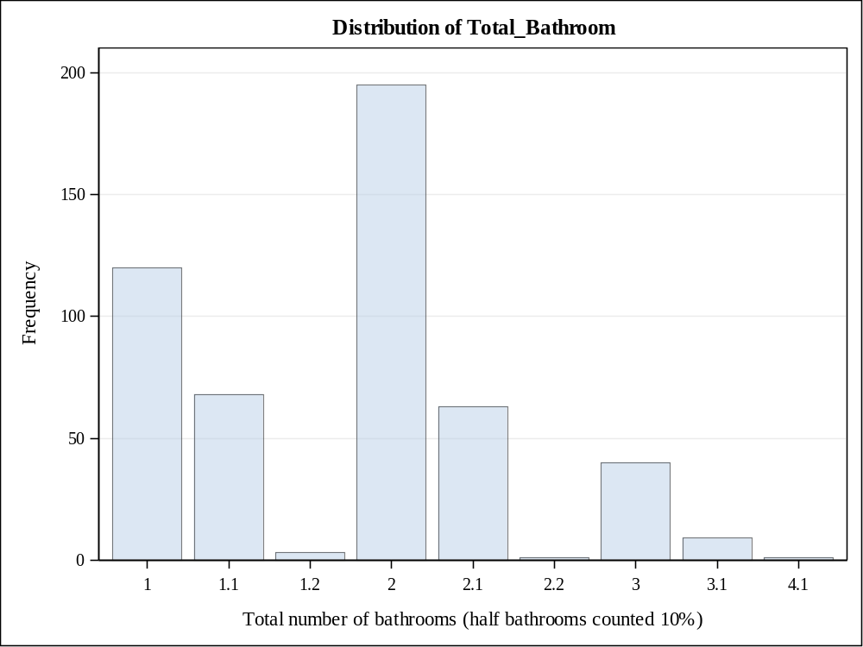

Season when house sold
Season_Sold | Frequency | Percent | Cumulative  Frequency | Cumulative  Percent
1 | 53 | 10.60 | 53 | 10.60
2 | 184 | 36.80 | 237 | 47.40
3 | 190 | 38.00 | 427 | 85.40
4 | 73 | 14.60 | 500 | 100.00

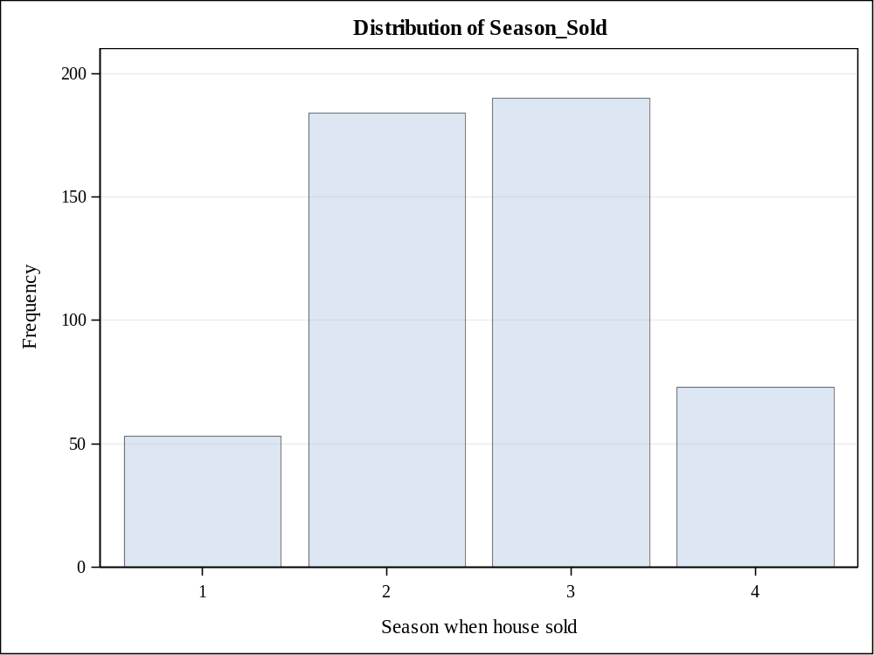

Garage attached or detached
Garage_Type_2 | Frequency | Percent | Cumulative  Frequency | Cumulative  Percent
Attached | 274 | 55.47 | 274 | 55.47
Detached | 179 | 36.23 | 453 | 91.70
NA | 41 | 8.30 | 494 | 100.00
Frequency Missing = 6

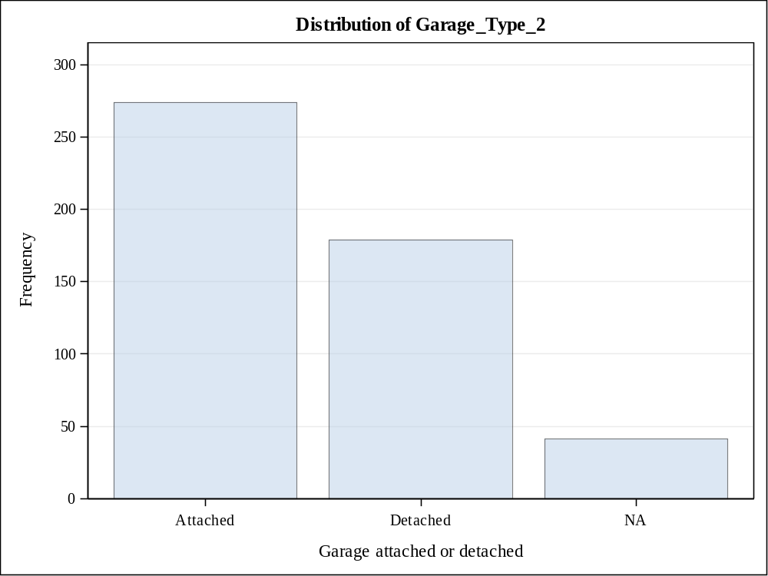

Foundation Type
Foundation_2 | Frequency | Percent | Cumulative  Frequency | Cumulative  Percent
Brick/Tile/Stone | 71 | 14.20 | 71 | 14.20
Cinder Block | 275 | 55.00 | 346 | 69.20
Concrete/Slab | 154 | 30.80 | 500 | 100.00

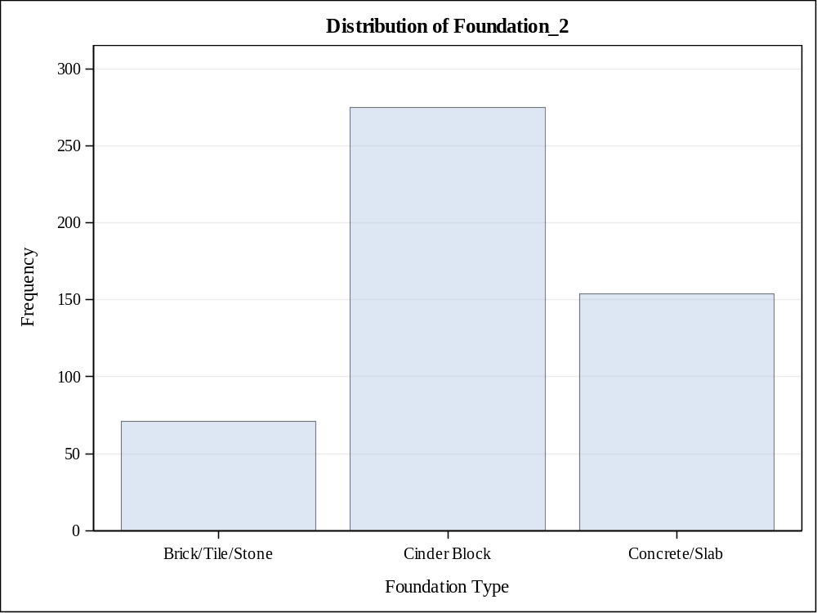

Masonry veneer or not
Masonry_Veneer | Frequency | Percent | Cumulative  Frequency | Cumulative  Percent
N | 345 | 69.14 | 345 | 69.14
Y | 154 | 30.86 | 499 | 100.00
Frequency Missing = 1

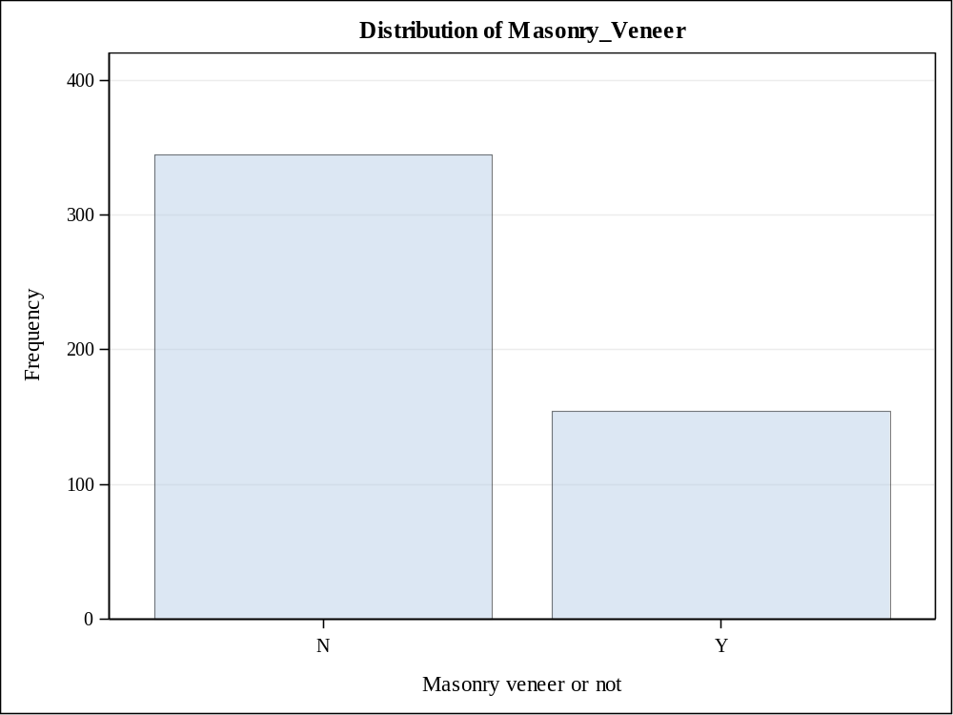

Regular or irregular lot shape
Lot_Shape_2 | Frequency | Percent | Cumulative  Frequency | Cumulative  Percent
Irregular | 145 | 29.12 | 145 | 29.12
Regular | 353 | 70.88 | 498 | 100.00
Frequency Missing = 2

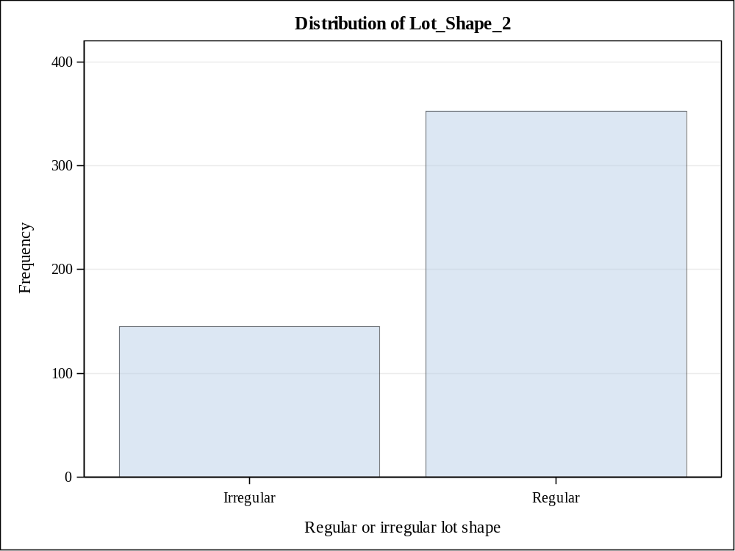

Style of dwelling
House_Style2 | Frequency | Percent | Cumulative  Frequency | Cumulative  Percent
1.5Fin | 53 | 10.60 | 53 | 10.60
1Story | 323 | 64.60 | 376 | 75.20
2Story | 63 | 12.60 | 439 | 87.80
SFoyer | 22 | 4.40 | 461 | 92.20
SLvl | 39 | 7.80 | 500 | 100.00

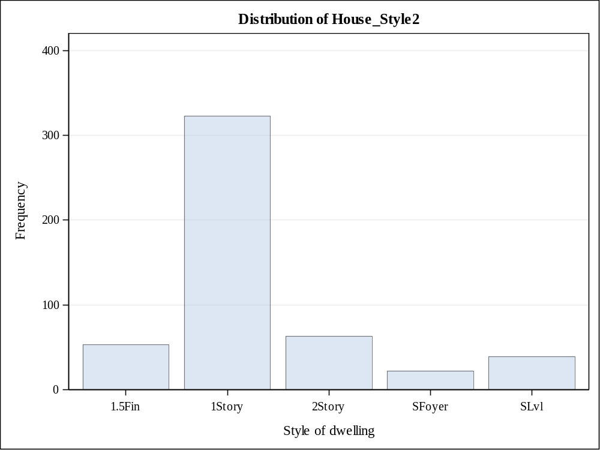

Overall material and finish of the house
Overall_Qual2 | Frequency | Percent | Cumulative  Frequency | Cumulative  Percent
4 | 74 | 14.80 | 74 | 14.80
5 | 209 | 41.80 | 283 | 56.60
6 | 217 | 43.40 | 500 | 100.00

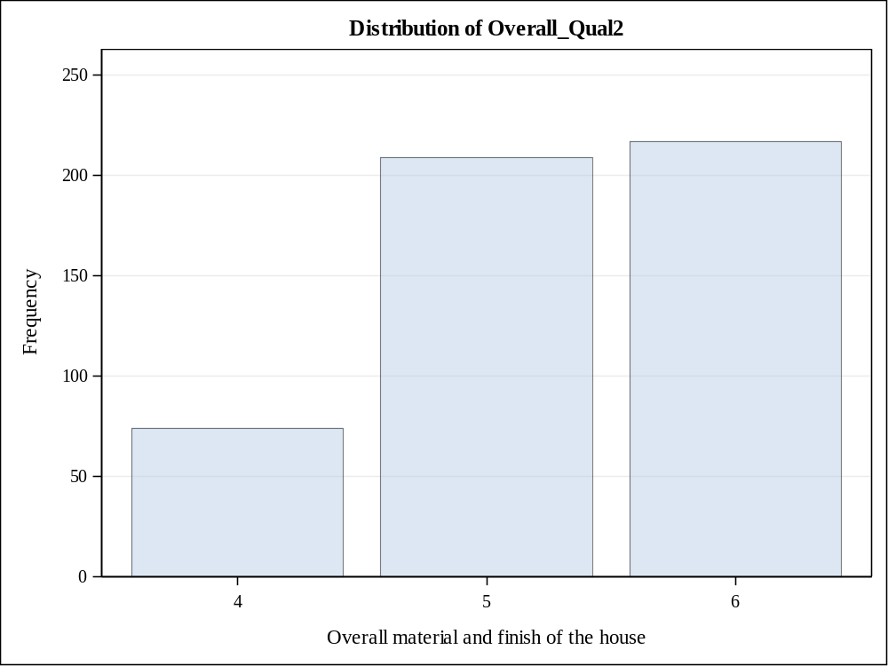

Overall condition of the house
Overall_Cond2 | Frequency | Percent | Cumulative  Frequency | Cumulative  Percent
4 | 24 | 4.80 | 24 | 4.80
5 | 220 | 44.00 | 244 | 48.80
6 | 256 | 51.20 | 500 | 100.00

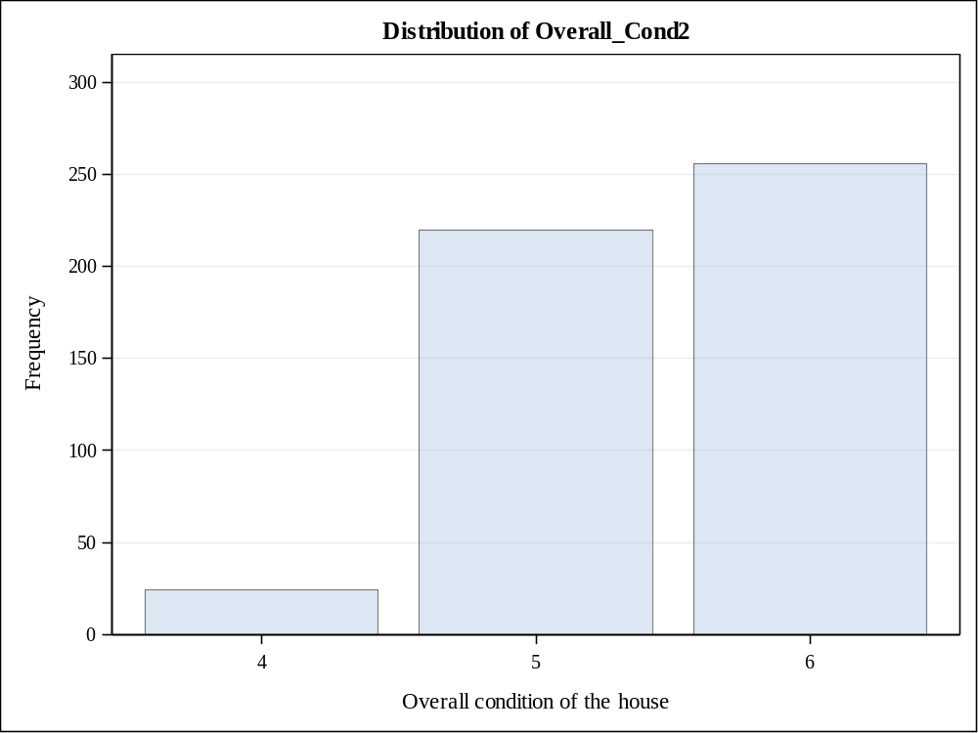

Sale Price > $175,000
Bonus | Frequency | Percent | Cumulative  Frequency | Cumulative  Percent
0 | 418 | 83.60 | 418 | 83.60
1 | 82 | 16.40 | 500 | 100.00

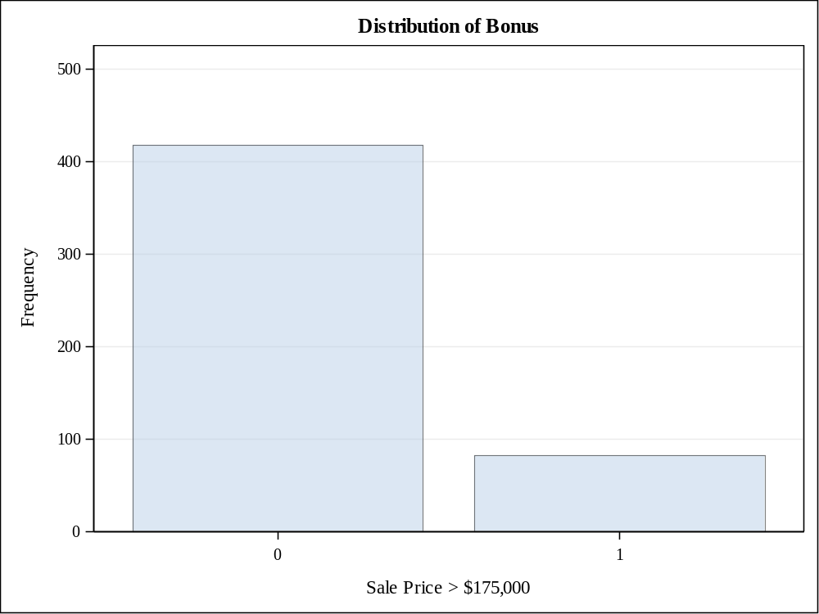

Question 3

Code Snippet
ods graphics on;
/* PROC TTest is used to test whether the mean of SalePrice is $135,000 */
proc ttest data=Project2.team12 h0=135000 plots(showh0) sides=2 alpha=0.05;
var SalePrice;
run;
ods graphics off;

Output
N | Mean | Std Dev | Std Err | Minimum | Maximum
500 | 140504 | 38216.5 | 1709.1 | 39300.0 | 290000

Mean | 95% CL Mean |  | Std Dev | 95% CL Std Dev
140504 | 137146 | 143862 | 38216.5 | 35985.6 | 40744.6

DF | t Value | Pr > |t|
499 | 3.22 | 0.0014

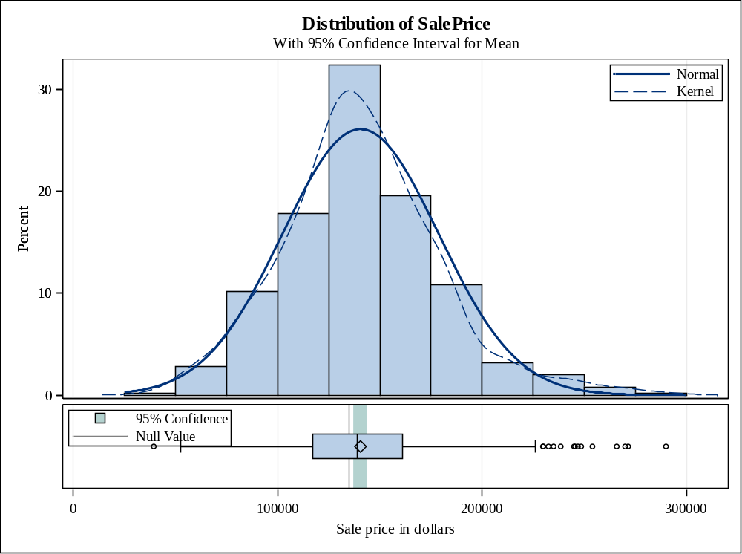

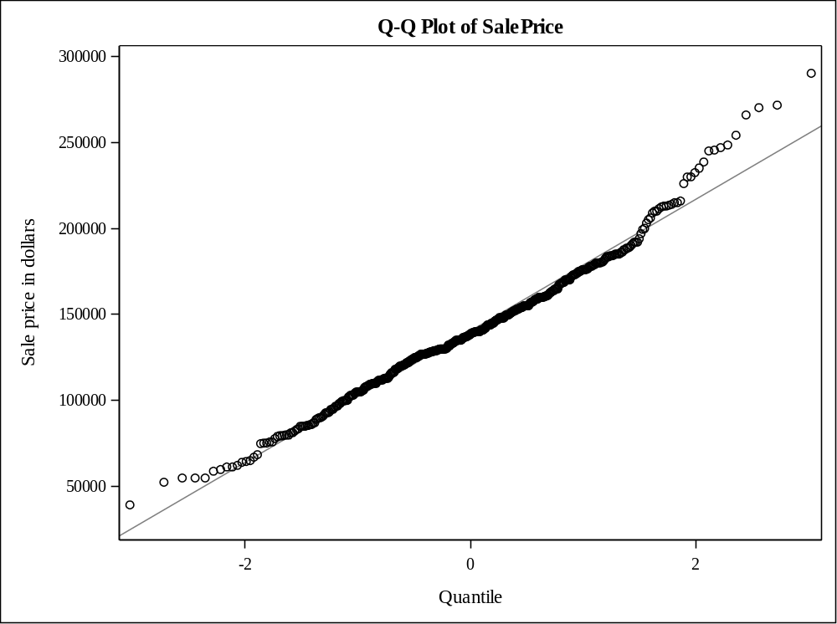

Question 4

Code Snippet

ods graphics on;
/* TTest is used to test whether the mean of SalePrice is the same for homes with or without masonry veneer */

proc ttest data=Project2.team12 plots(showh0) sides=2 alpha=0.05;

class Masonry_Veneer;

var SalePrice;

run;

ods graphics off;

Output

Masonry_Veneer | N | Mean | Std Dev | Std Err | Minimum | Maximum
N | 345 | 132423 | 36604.1 | 1970.7 | 39300.0 | 290000
Y | 154 | 158376 | 35691.4 | 2876.1 | 61500.0 | 265900
Diff (1-2) |  | -25952.8 | 36325.6 | 3520.4

Masonry_Veneer | Method | Mean |  | 95% CL Mean |  | Std Dev | 95% CL Std Dev
N |  | 132423 | 128547 |  | 136300 | 36604.1 | 34061.4 | 39560.2
Y |  | 158376 | 152694 |  | 164058 | 35691.4 | 32101.1 | 40193.2
Diff (1-2) | Pooled | -25952.8 | -32869.5 |  | -19036.0 | 36325.6 | 34201.0 | 38733.7
Diff (1-2) | Satterthwaite | -25952.8 | -32813.7 |  | -19091.8

Method | Variances | DF | t Value | Pr > |t|
Pooled | Equal | 497 | -45.72 | <.0001
Satterthwaite | Unequal | 300.89 | -46.16 | <.0001

Equality of Variances
Method | Num DF | Den DF | F Value | Pr > F
Folded F | 344 | 153 | 1.05 | 0.7277

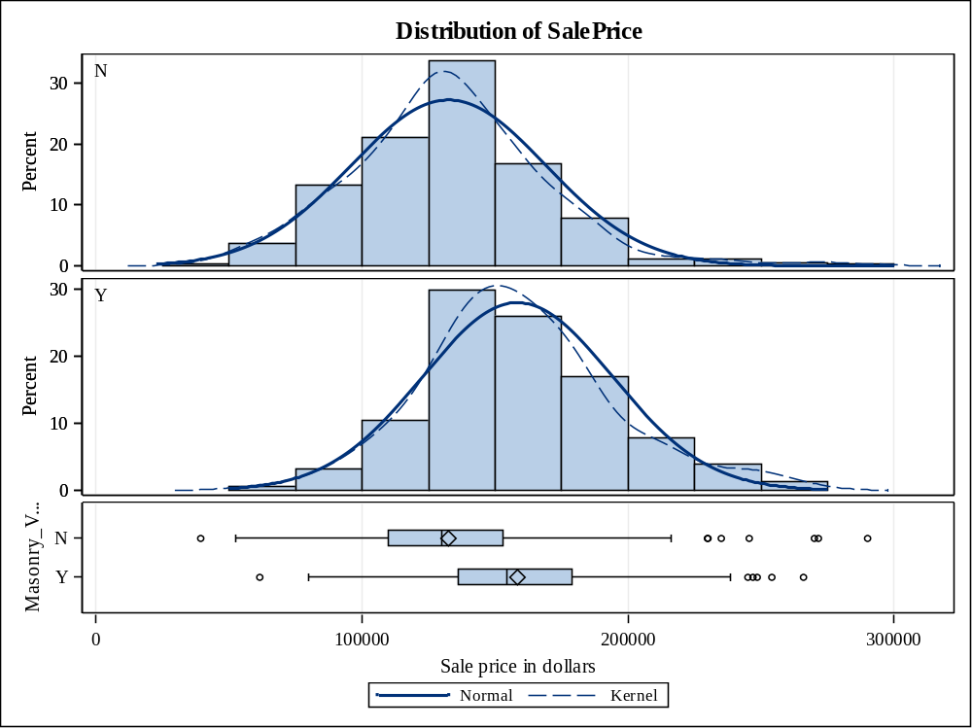

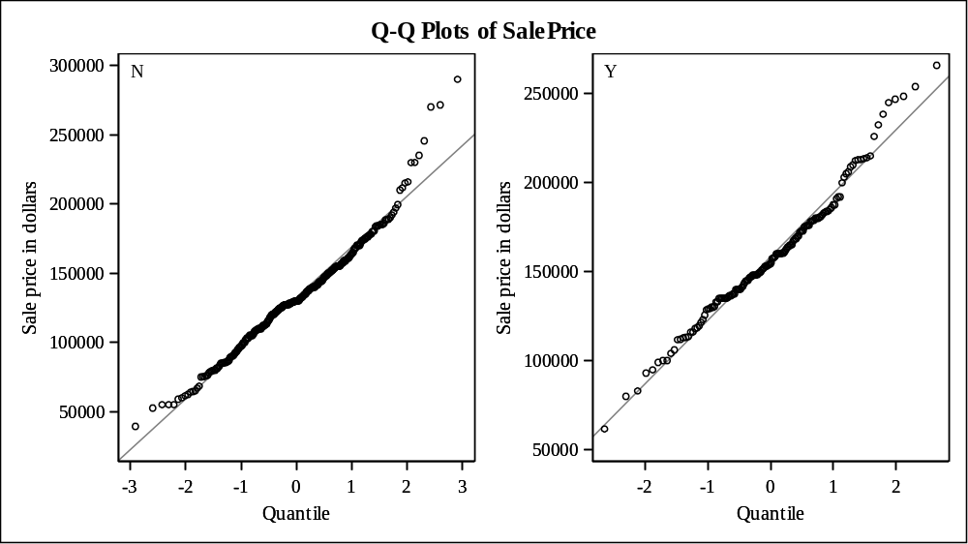

Question 5

Code Snippet
/* The following code defines macro variable for numerical variables (excluding SalePrice)*/
%Let interval_pred=Lot_Area Gr_Liv_Area Garage_Area Basement_Area Deck_Porch_Area Age_Sold Log_Price;

/* The following code generates scatter plots to show relationships between continuous predictors and SalePrice */
proc corr data= Project2.team12 rank
plots(only)=scatter(nvar=all ellipse=none);
var &interval_pred;
with SalePrice;
id PID;
title "Correlations and Scatter Plots";

/*The following code generates box plots to show relationships between categorical predictor House_style and SalePrice */
proc sgplot data=Project2.team12;
vbox SalePrice/ category=House_Style
connect=mean;
title "Sale Price Differences across House_Style";
run;

/*The following code generates box plots to show relationships between categorical predictor Overall_Qual and SalePrice */
proc sgplot data=Project2.team12;
vbox SalePrice/ category=Overall_Qual
connect=mean;
title "Sale Price Differences across Overall_Qual";
run;

/*The following code generates box plots to show relationships between categorical predictor Overall_Cond and SalePrice */
proc sgplot data=Project2.team12;
vbox SalePrice/ category=Overall_Cond
connect=mean;
title "Sale Price Differences across Overall_Cond";
run;

/*The following code generates box plots to show relationships between categorical predictor Heating_Qc and SalePrice */
proc sgplot data=Project2.team12;
vbox SalePrice/ category=Heating_QC
connect=mean;
title "Sale Price Differences across Heating_QC";
run;

/*The following code generates box plots to show relationships between categorical predictor Central_Air and SalePrice */
proc sgplot data=Project2.team12;
vbox SalePrice/ category=Central_Air
connect=mean;
title "Sale Price Differences across Central_Air";
run;

/*The following code generates box plots to show relationships between categorical predictor Bedroom_AbvGr and SalePrice */
proc sgplot data=Project2.team12;
vbox SalePrice/ category=Bedroom_AbvGr
connect=mean;
title "Sale Price Differences across Bedroom_AbvGr";
run;

/*The following code generates box plots to show relationships between categorical predictor Fireplaces and SalePrice */
proc sgplot data=Project2.team12;
vbox SalePrice/ category=Fireplaces
connect=mean;
title "Sale Price Differences across Fireplaces";
run;

/*The following code generates box plots to show relationships between categorical predictor Mo_Sold and SalePrice */
proc sgplot data=Project2.team12;
vbox SalePrice/ category=Mo_Sold
connect=mean;
title "Sale Price Differences across Mo_Sold";
run;

/*The following code generates box plots to show relationships between categorical predictor Full_Bathroom and SalePrice */
proc sgplot data=Project2.team12;
vbox SalePrice/ category=Full_Bathroom
connect=mean;
title "Sale Price Differences across Full_Bathroom";
run;

/*The following code generates box plots to show relationships between categorical predictor Half_Bathroom and SalePrice */
proc sgplot data=Project2.team12;
vbox SalePrice/ category=Half_Bathroom
connect=mean;
title "Sale Price Differences across Half_Bathroom";
run;

/*The following code generates box plots to show relationships between categorical predictor Total_Bathroom and SalePrice */
proc sgplot data=Project2.team12;
vbox SalePrice/ category=Total_Bathroom
connect=mean;
title "Sale Price Differences across Total_Bathroom";
run;

/*The following code generates box plots to show relationships between categorical predictor Seasonal_Sold and SalePrice */
proc sgplot data=Project2.team12;
vbox SalePrice/ category=Season_Sold
connect=mean;
title "Sale Price Differences across Season_Sold";
run;

/*The following code generates box plots to show relationships between categorical predictor Garage_Type_2 and SalePrice */
proc sgplot data=Project2.team12;
vbox SalePrice/ category=Garage_Type_2
connect=mean;
title "Sale Price Differences across Garage_Type_2";
run;

/*The following code generates box plots to show relationships between categorical predictor Foundation_2 and SalePrice */
proc sgplot data=Project2.team12;
vbox SalePrice/ category=Foundation_2
connect=mean;
title "Sale Price Differences across Foundation_2";
run;

/*The following code generates box plots to show relationships between categorical predictor Masonary_Veneer and SalePrice */
proc sgplot data=Project2.team12;
vbox SalePrice/ category=Masonry_Veneer
connect=mean;
title "Sale Price Differences across Masonry_Veneer";
run;

/*The following code generates box plots to show relationships between categorical predictor Lot_Shape_2 and SalePrice */
proc sgplot data=Project2.team12;
vbox SalePrice/ category=Lot_Shape_2
connect=mean;
title "Sale Price Differences across Lot_Shape_2";
run;

/*The following code generates box plots to show relationships between categorical predictor House_Style2 and SalePrice */
proc sgplot data=Project2.team12;
vbox SalePrice/ category=House_Style2
connect=mean;
title "Sale Price Differences across House_Style2";
run;

/*The following code generates box plots to show relationships between categorical predictor Overall_Qual2 and SalePrice */
proc sgplot data=Project2.team12;
vbox SalePrice/ category=Overall_Qual2
connect=mean;
title "Sale Price Differences across Overall_Qual2";
run;

/*The following code generates box plots to show relationships between categorical predictor Overall_Cond2 and SalePrice */
proc sgplot data=Project2.team12;
vbox SalePrice/ category=Overall_Cond2
connect=mean;
title "Sale Price Differences across Overall_Cond2";
run;

/*The following code generates box plots to show relationships between categorical predictor Bonus and SalePrice */
proc sgplot data=Project2.team12;
vbox SalePrice/ category=Bonus
connect=mean;
title "Sale Price Differences across Bonus";
run;

/*The following code generates box plots to show relationships between categorical predictor Foundation_2 and SalePrice */
proc boxplot data=Project2.team12;
plot SalePrice*Mo_Sold;
run;

Output
- The scatter plots for categorical variables are given below.
1 With Variables: | SalePrice
8 Variables: | Lot_Area Gr_Liv_Area Garage_Area SalePrice Basement_Area Deck_Porch_Area Age_Sold Log_Price

Simple Statistics
Variable | N | Mean | Std Dev | Sum | Minimum | Maximum | Label
SalePrice | 500 | 140504 | 38217 | 70252040 | 39300 | 290000 | Sale price in dollars
Lot_Area | 500 | 8550 | 3655 | 4274802 | 1300 | 41600 | Lot size in square feet
Gr_Liv_Area | 500 | 1147 | 231.73728 | 573534 | 334.00000 | 1500 | Above grade (ground) living area square feet
Garage_Area | 500 | 393.25400 | 186.47874 | 196627 | 0 | 1488 | Size of garage in square feet
Basement_Area | 500 | 912.63000 | 323.24482 | 456315 | 0 | 1645 | Basement area in square feet
Deck_Porch_Area | 500 | 121.43200 | 130.92050 | 60716 | 0 | 804.00000 | Total area of decks and porches in square feet
Age_Sold | 500 | 44.04600 | 27.03149 | 22023 | 1.00000 | 118.00000 | Age of house when sold, in years
Log_Price | 500 | 11.81405 | 0.28730 | 5907 | 10.57898 | 12.57764 | Natural log of the sale price

Pearson Correlation Coefficients, N = 500
Prob > |r| under H0: Rho=0
SalePrice  Sale price in dollars | SalePrice  1.00000 | Log_Price  0.97397  <.0001 | Age_Sold  -0.65367  <.0001 | Basement_Area  0.61521  <.0001 | Gr_Liv_Area  0.59697  <.0001 | Garage_Area  0.52736  <.0001 | Deck_Porch_Area  0.42642  <.0001 | Lot_Area  0.28704  <.0001

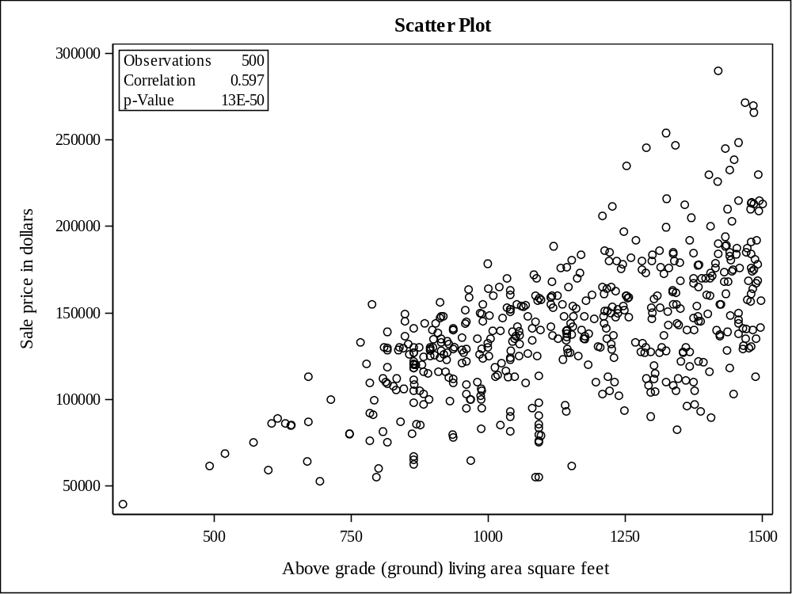

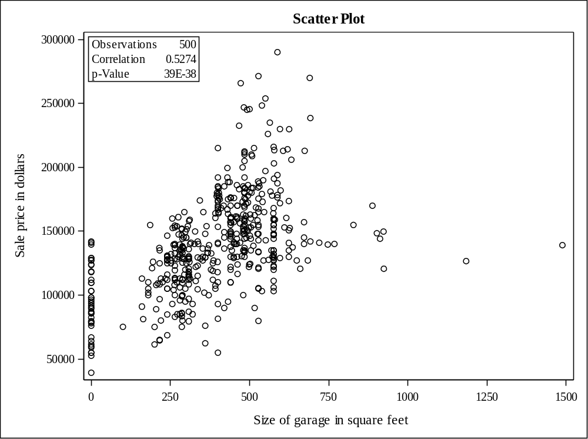

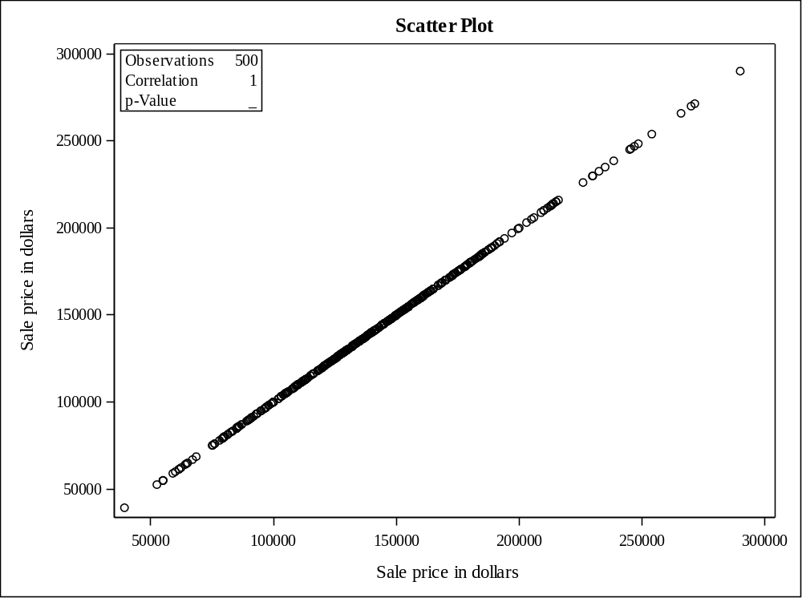

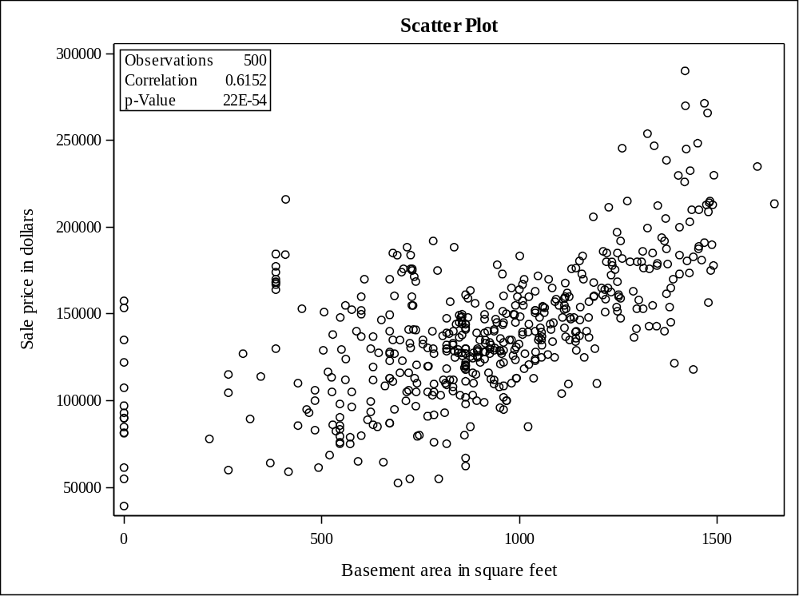

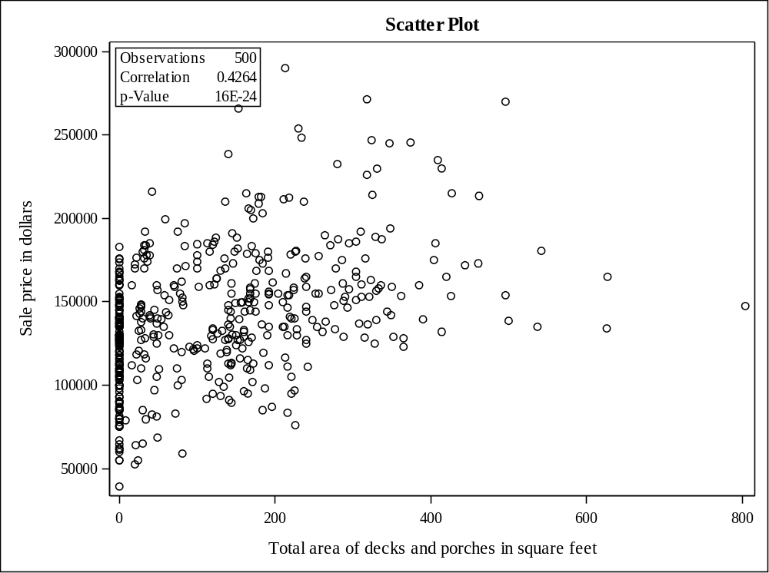

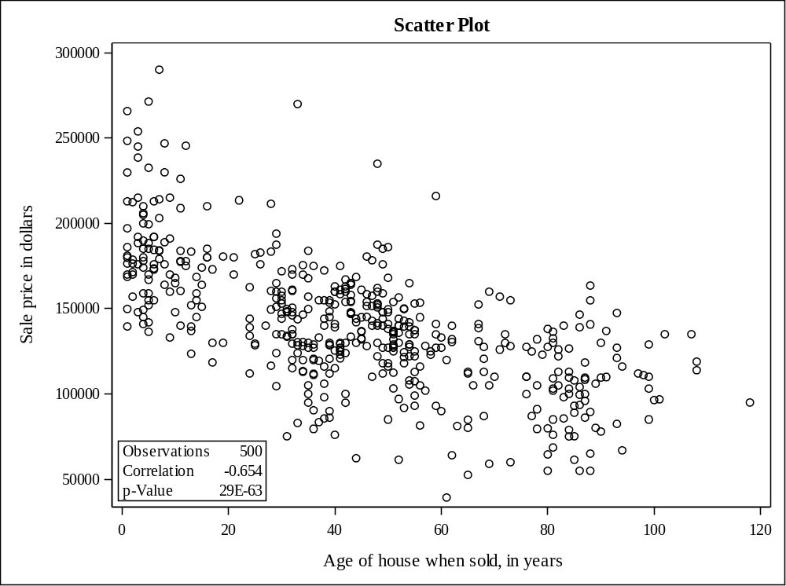

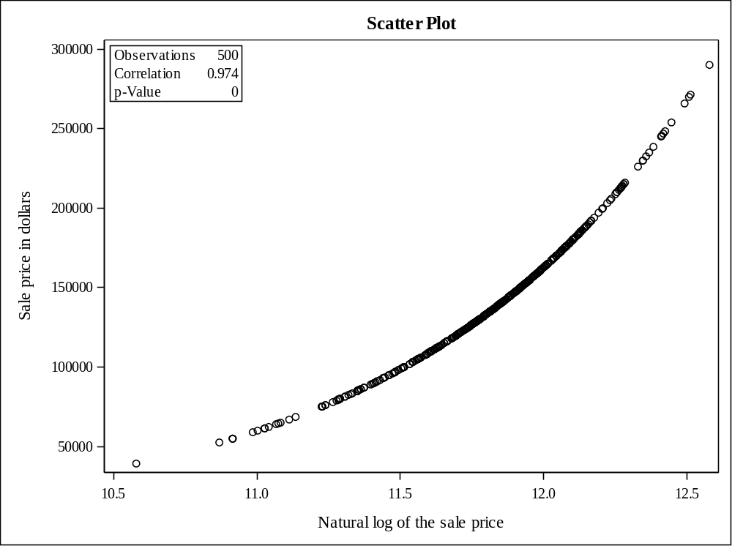

- The comparative box plots for categorical variables are given below.
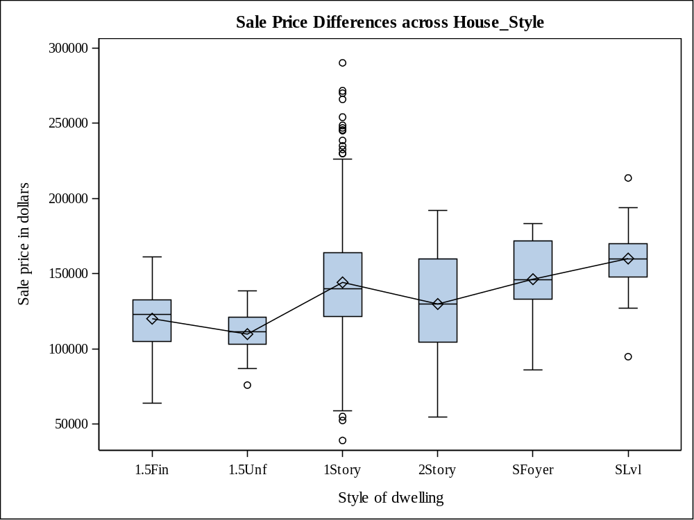

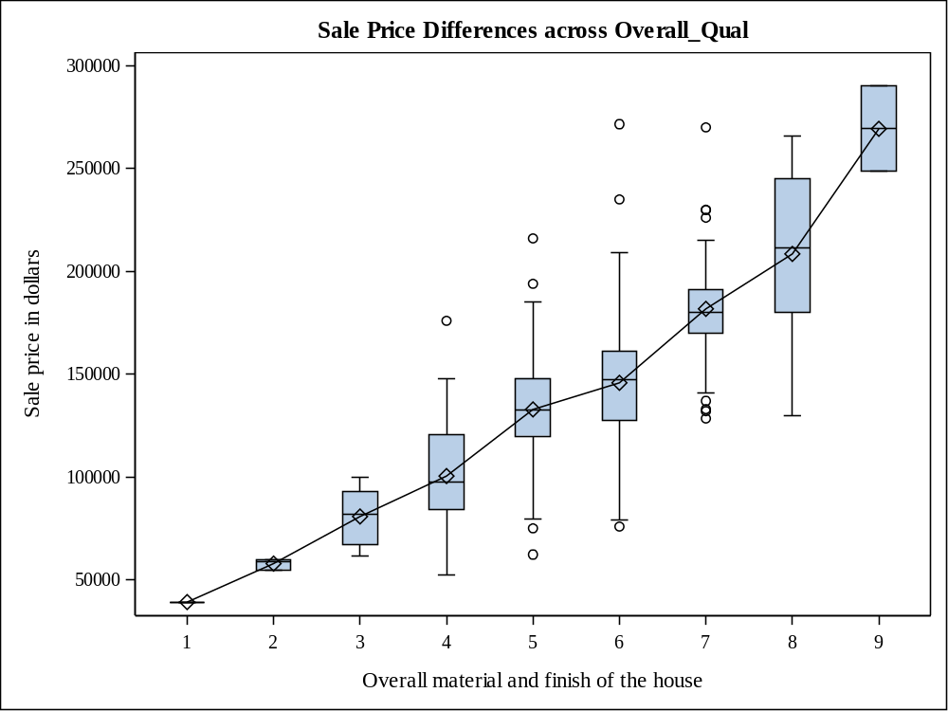
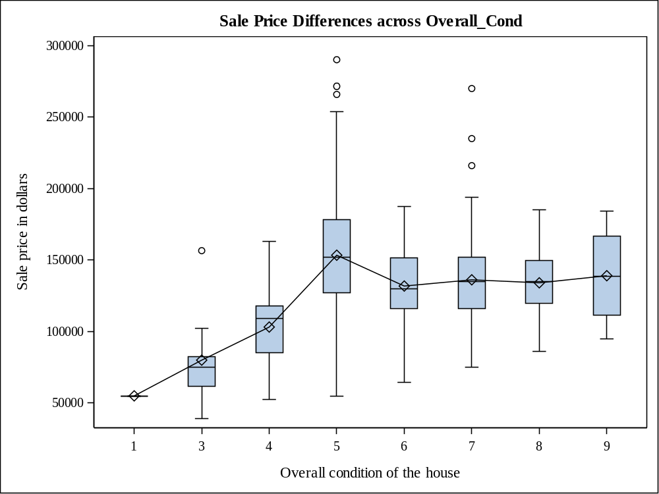

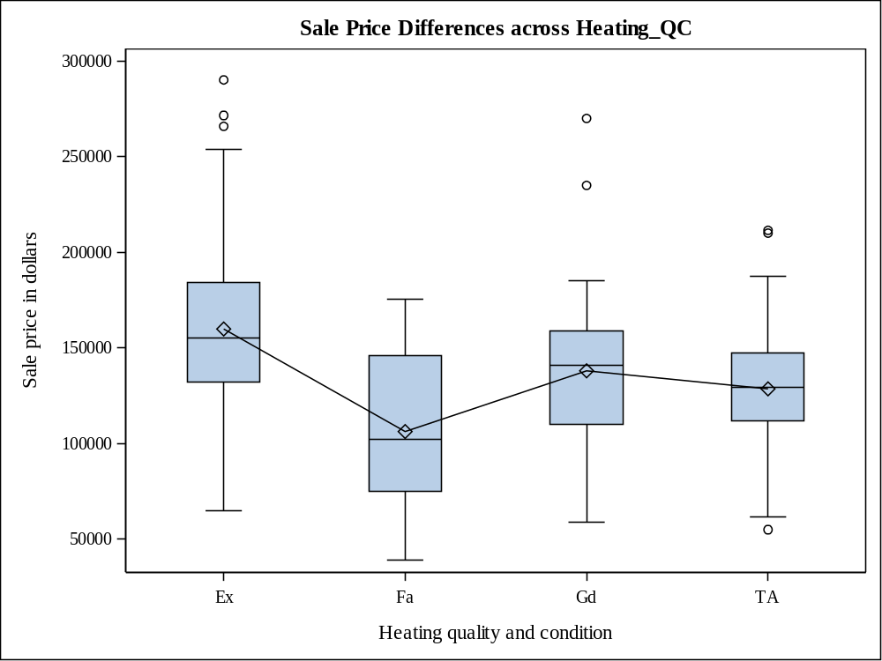
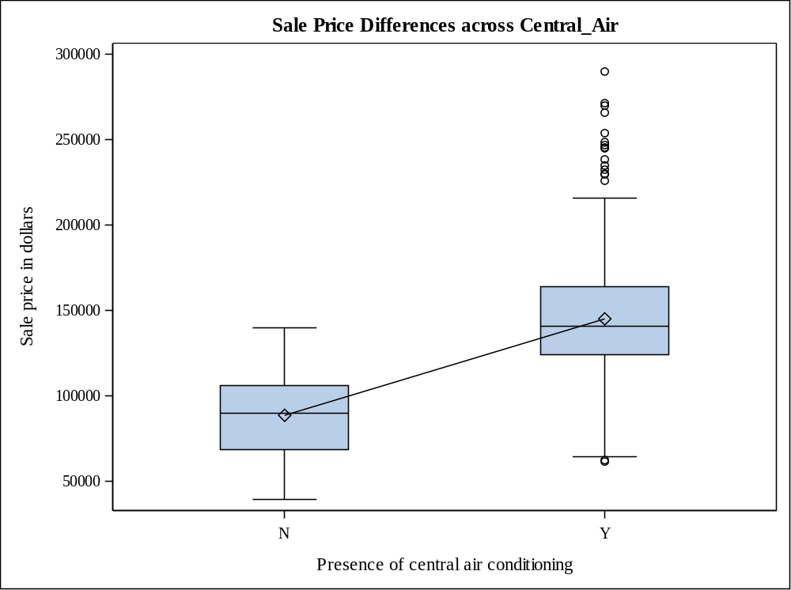

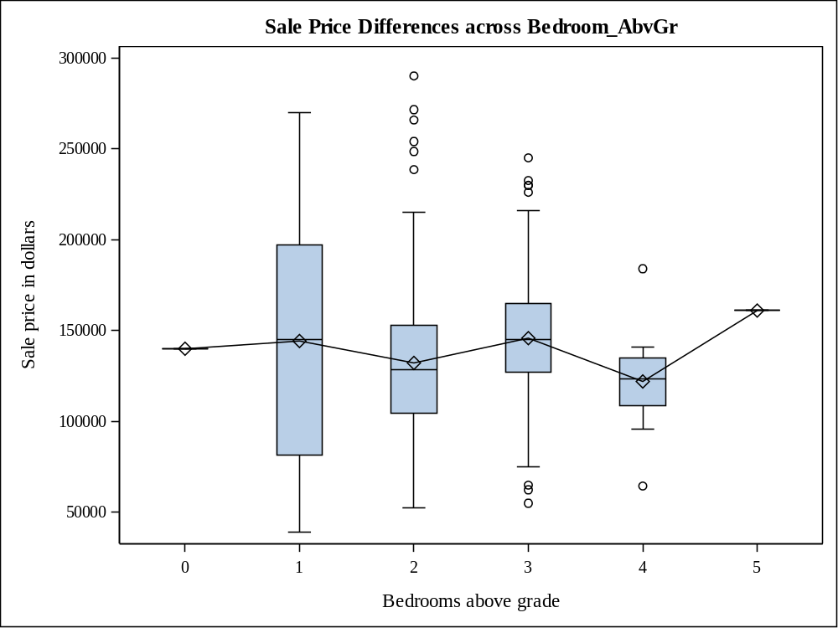

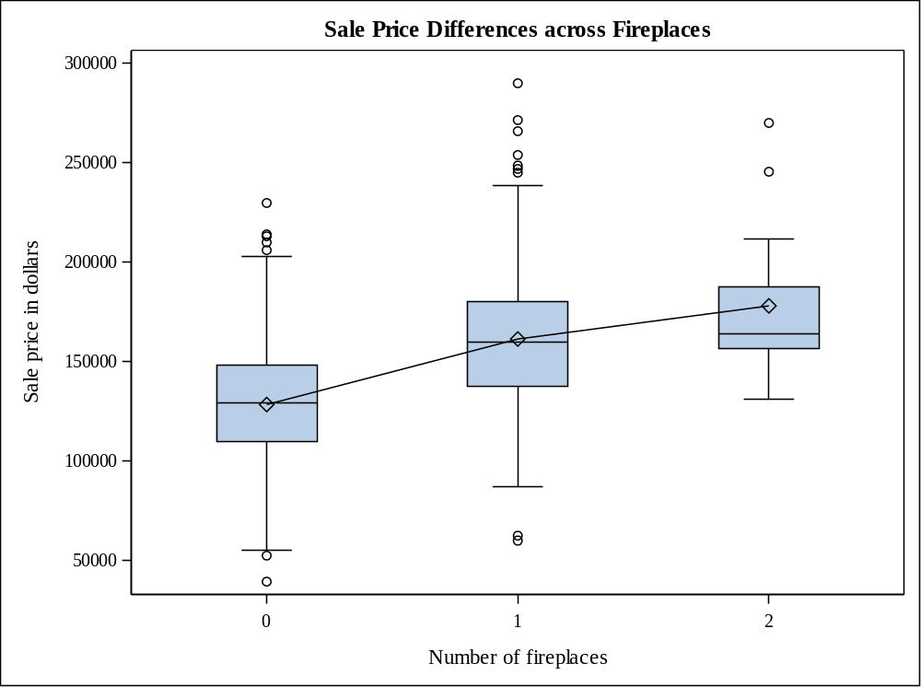
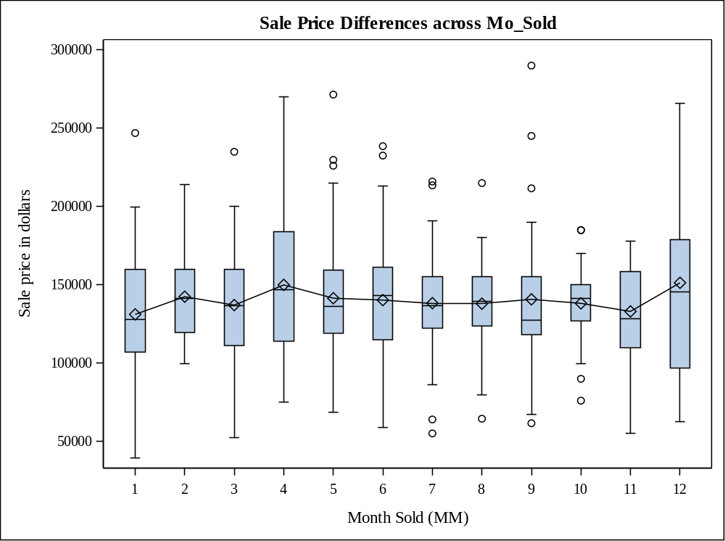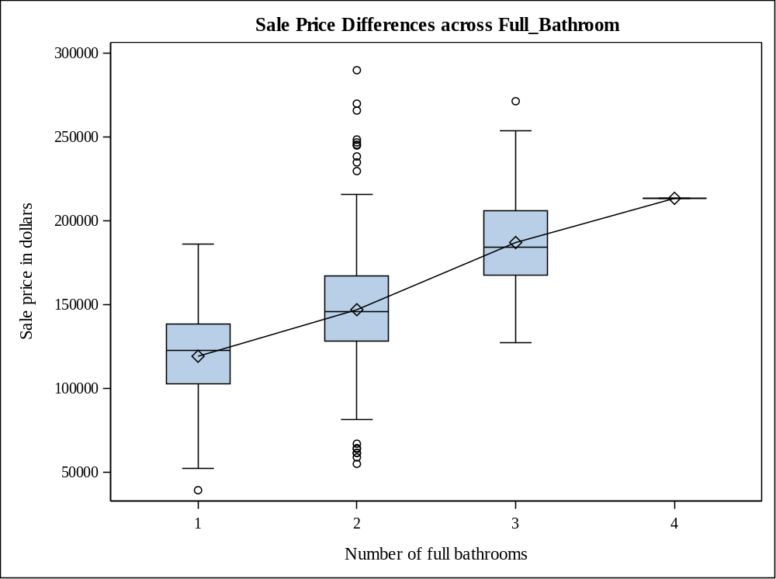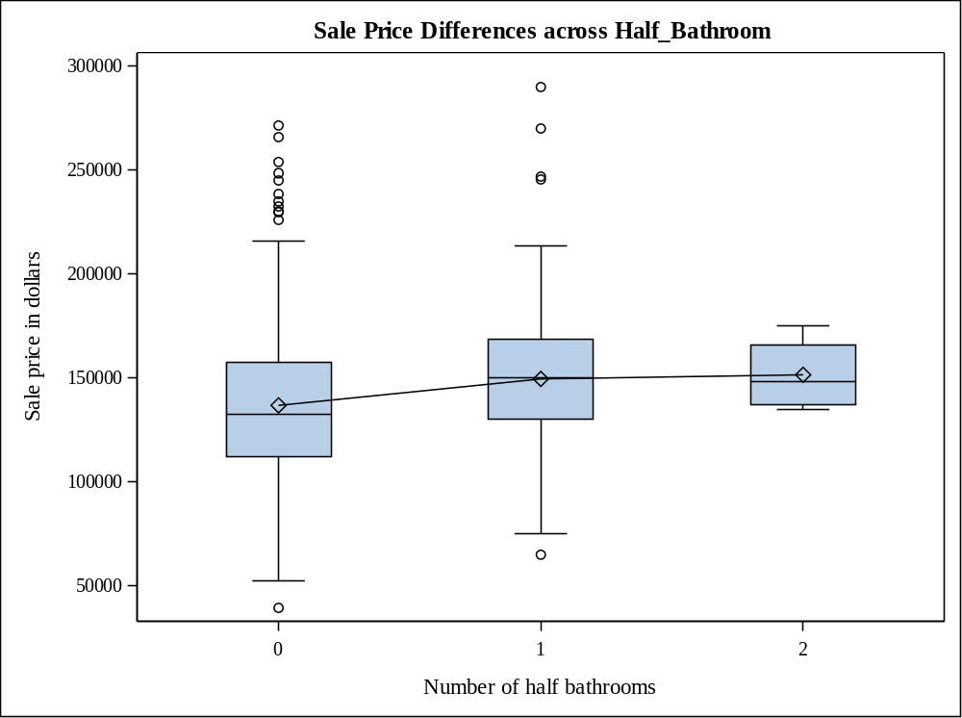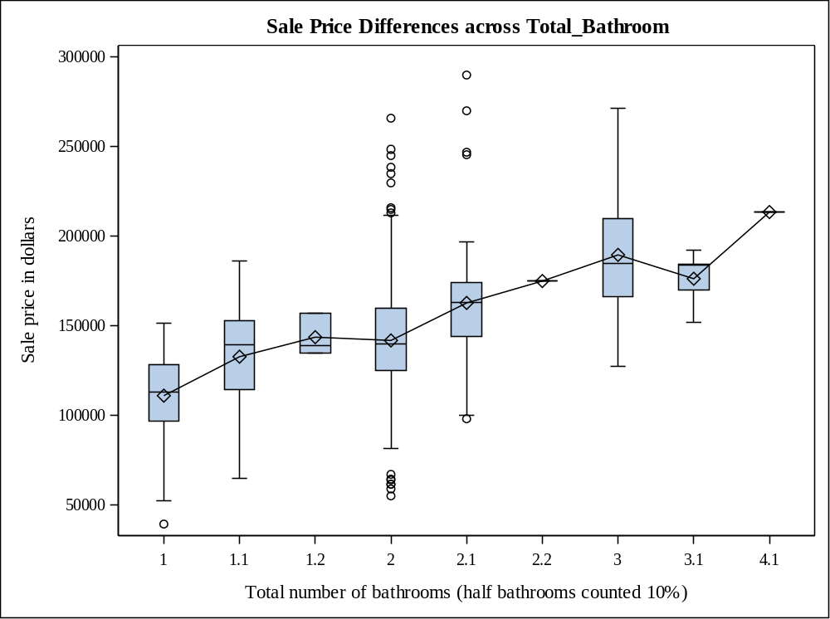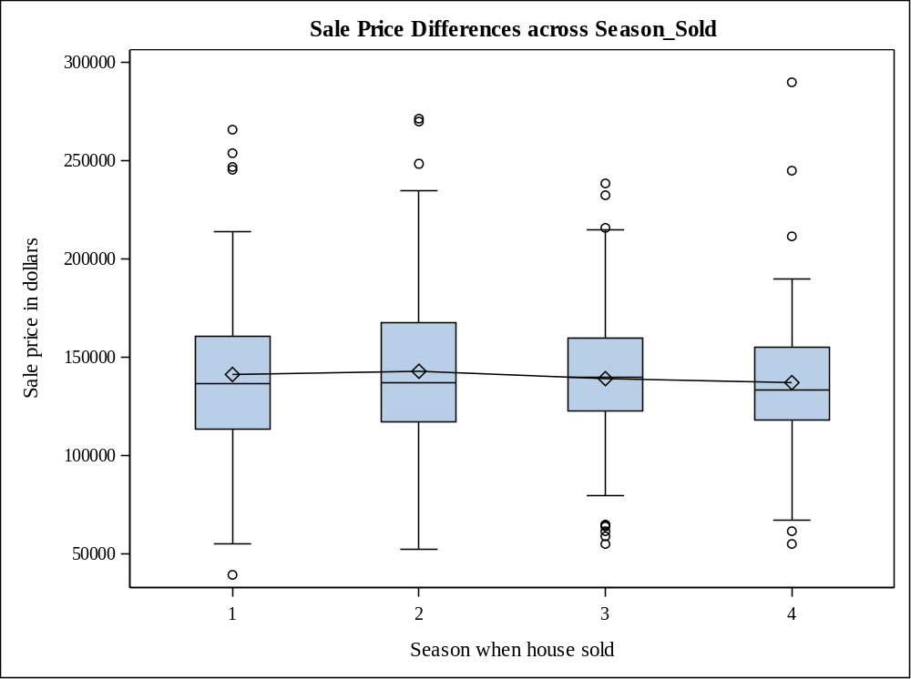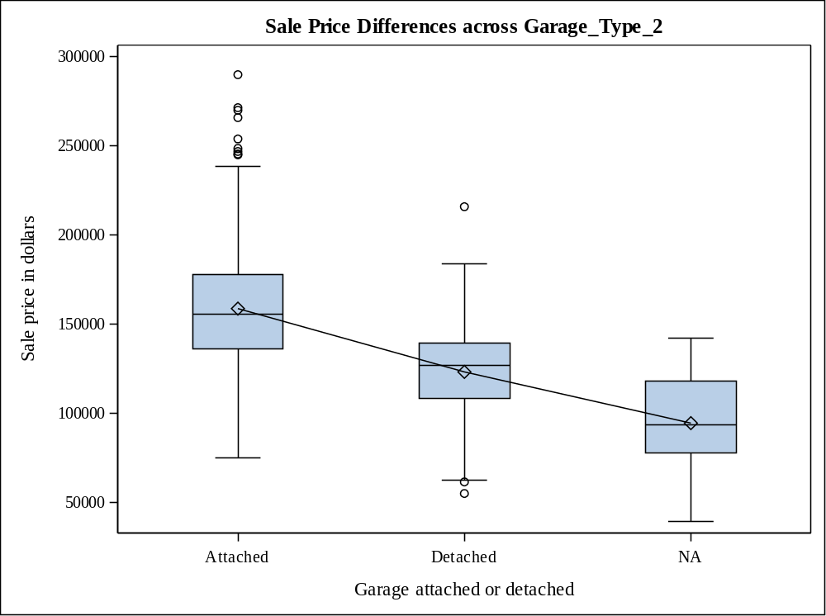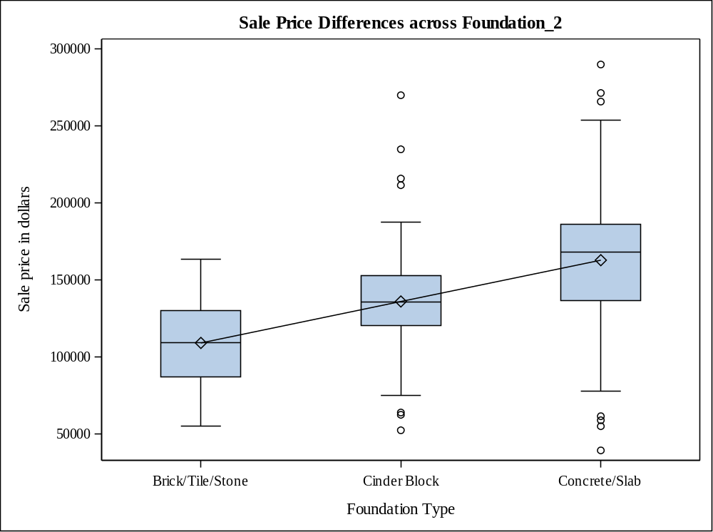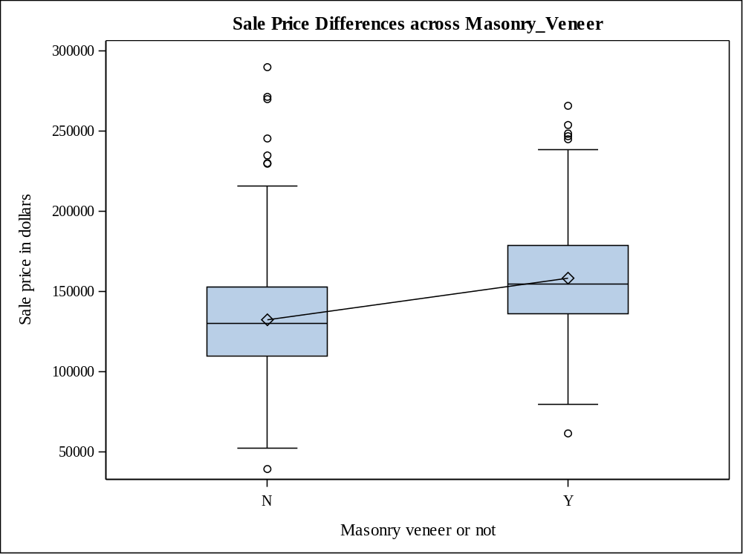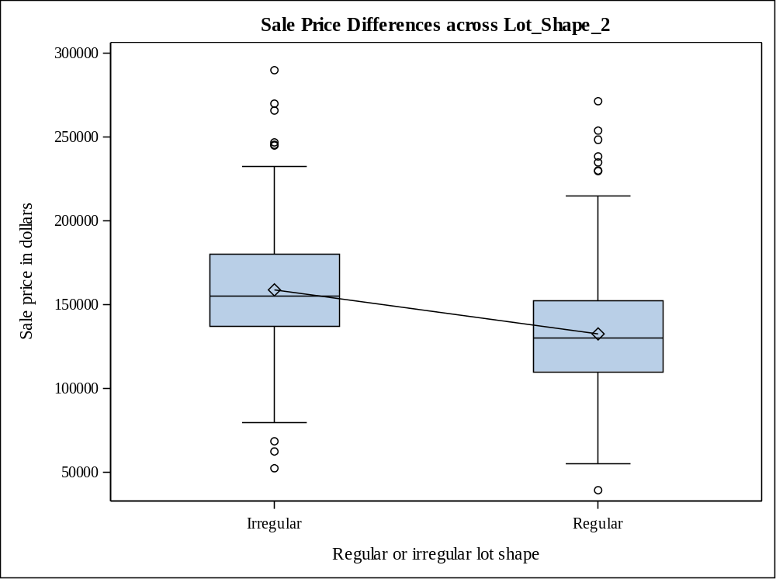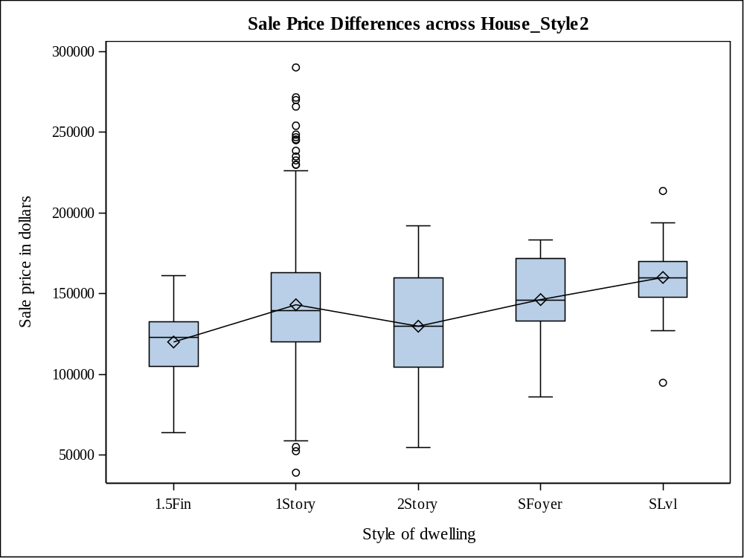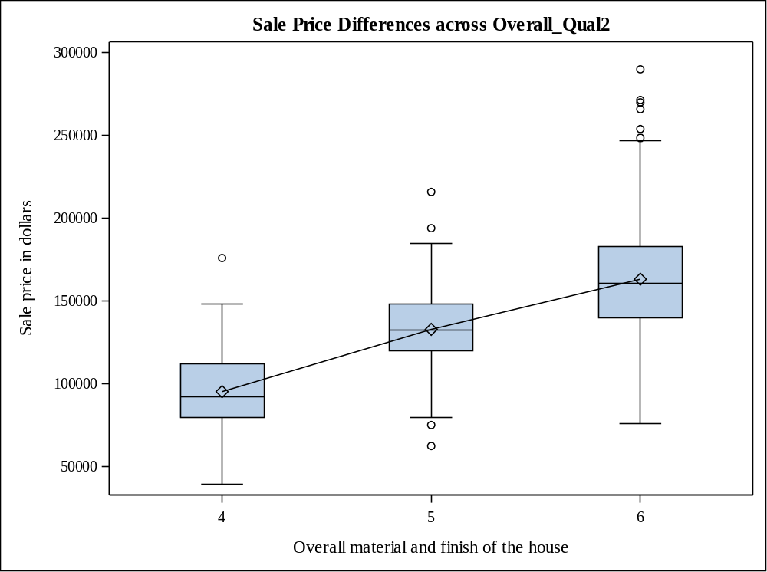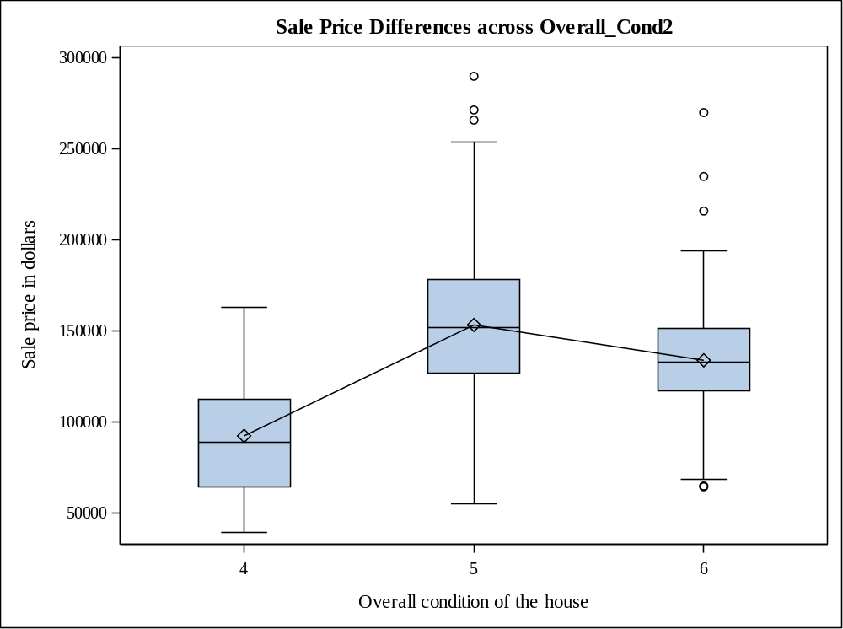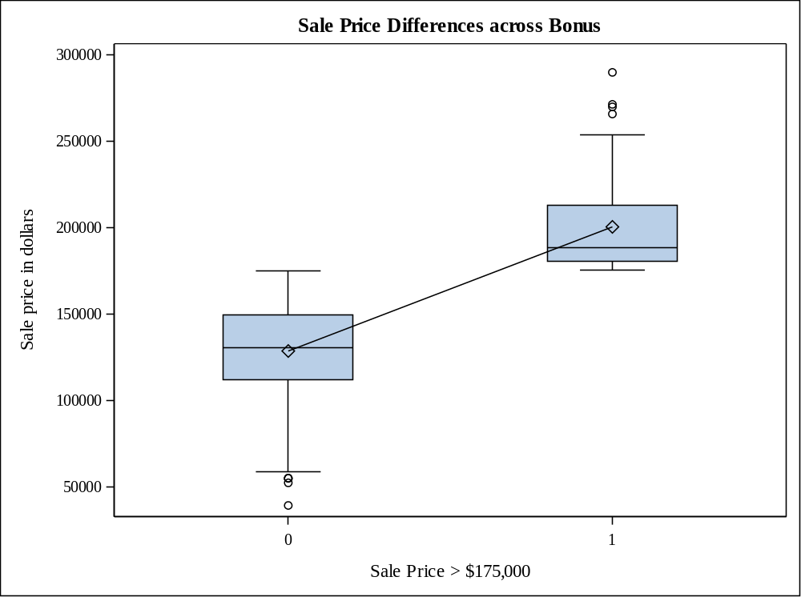

Question 6

Code Snippet

ods graphics on;
/* The following code performs analysis of variance with SalePrice as the response variable and Heating_QC as the categorical predictor variable (Levene’s test of homogeneity of variances) */

proc glm data=Project2.team12 plot=diagnostics;

class Heating_QC;

model SalePrice = Heating_QC;

means Heating_QC / alpha=0.05 hovtest=LEVENE;

run;ods graphics off;

Output

Class Level Information
Class | Levels | Values
Heating_QC | 4 | Ex Fa Gd TA

Number of Observations Read | 500
Number of Observations Used | 500

Source | DF | Sum of Squares | Mean Square | F Value | Pr > F
Model | 3 | 128877532388 | 42959177463 | 35.52 | <.0001
Error | 496 | 599914182079 | 1209504399.4
Corrected Total | 499 | 728791714467

R-Square | Coeff Var | Root MSE | SalePrice Mean
0.176837 | 24.75226 | 34777.93 | 140504.1

Source | DF | Type I SS | Mean Square | F Value | Pr > F
Heating_QC | 3 | 128877532388 | 42959177463 | 35.52 | <.0001

Source | DF | Type III SS | Mean Square | F Value | Pr > F
Heating_QC | 3 | 128877532388 | 42959177463 | 35.52 | <.0001

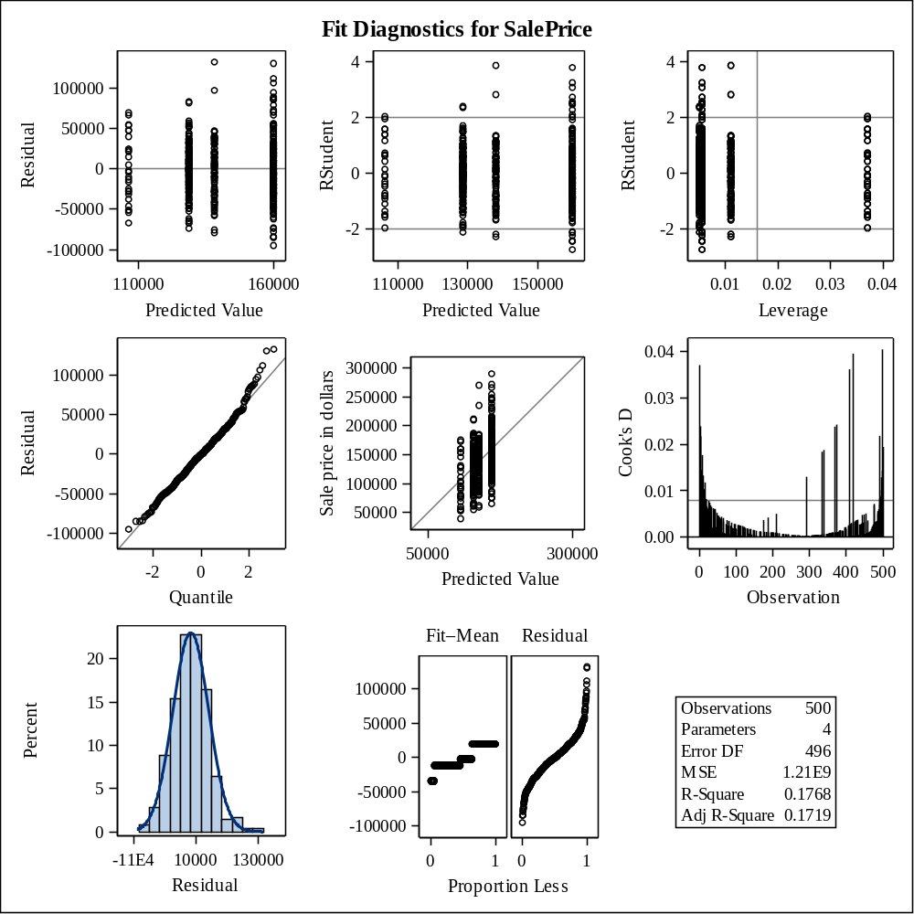
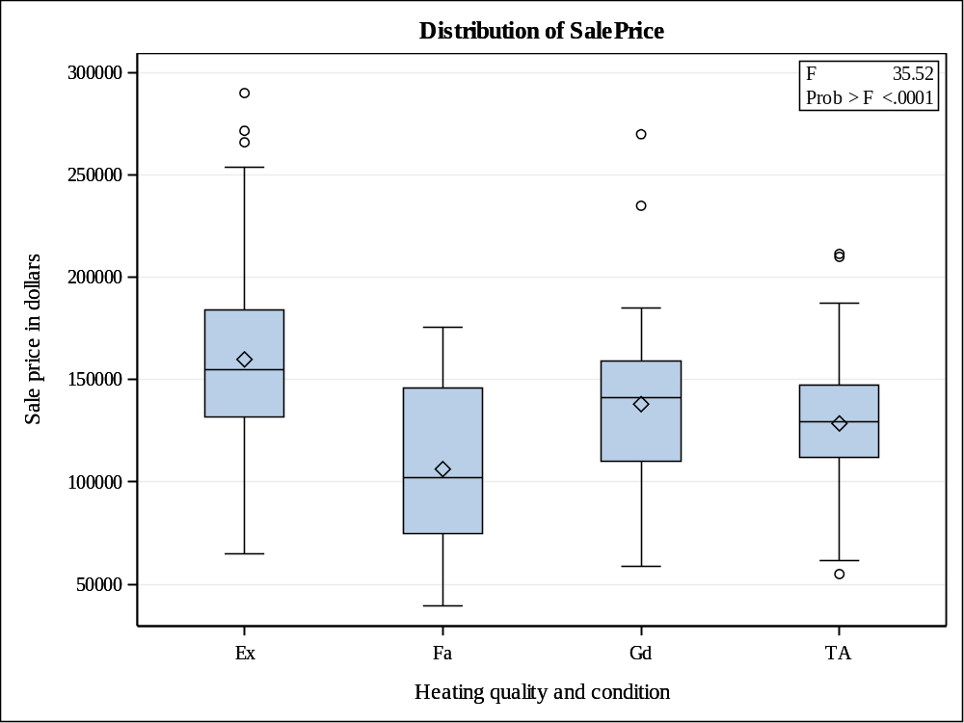

Levene's Test for Homogeneity of SalePrice Variance
ANOVA of Absolute Deviations from Group Means
Source | DF | Sum of Squares | Mean Square | F Value | Pr > F
Heating_QC | 3 | 1.155E10 | 3.8505E9 | 8.33 | <.0001
Error | 496 | 2.292E11 | 4.621E8

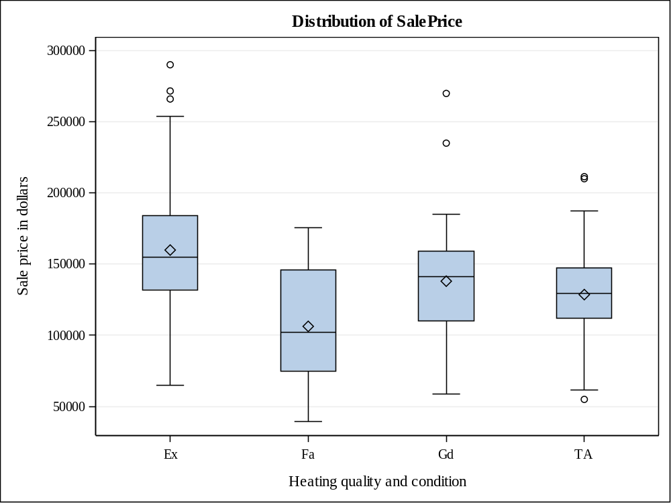

Level of  Heating_QC | N | SalePrice
Level of  Heating_QC | N | Mean | Std Dev
Ex | 182 | 159892.170 | 40119.7287
Fa | 27 | 106298.148 | 40583.5854
Gd | 91 | 138027.363 | 35152.8744
TA | 200 | 128605.625 | 27867.2366

Question 7

Code Snippet

ods graphics on;
/* The following code uses LSMEANS statement in PROC GLM to produce comparison information about
the mean sale prices of the different heating system quality ratings */

proc glm data=Project2.team12 plot=diagnostics; class Heating_QC;

model SalePrice = Heating_QC;

lsmeans Heating_QC;

run;

ods graphics off;

Output
Heating_QC | SalePrice LSMEAN
Ex | 159892.170
Fa | 106298.148
Gd | 138027.363
TA | 128605.625
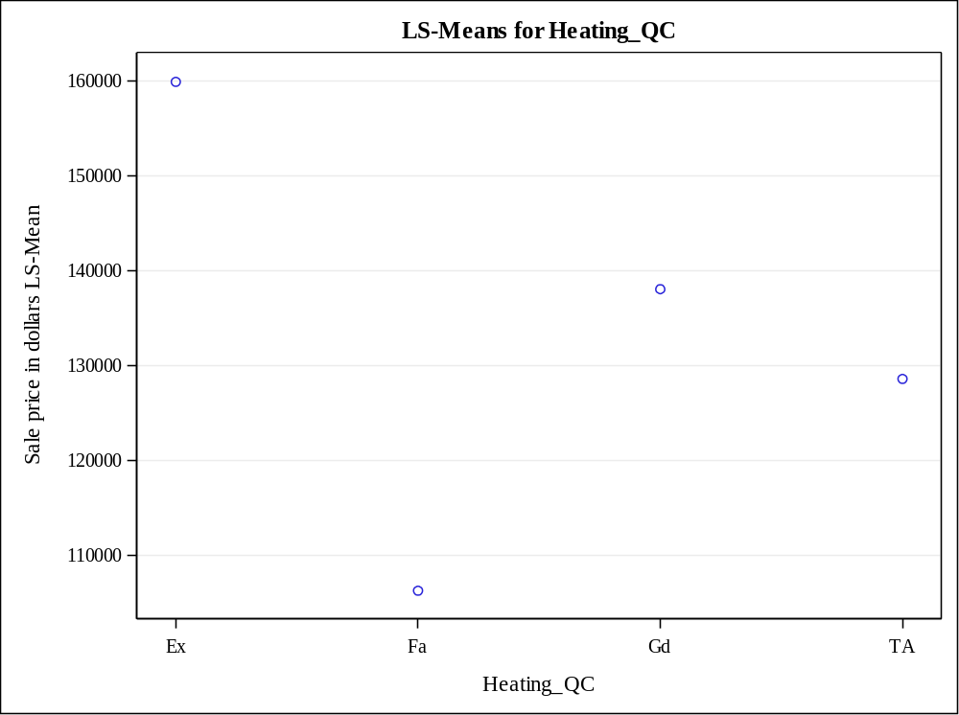

Question 8

Code Snippet

ods graphics on;
/* The following code uses CORR statement to examine the relationships between SalePrice and the continuous predictor variables in the data set */

title "Relationships between SalePrice and the continuous predictor variables in the data set";
proc corr data=Project2.team12 plots=scatter(nvar=all);
var &interval_pred;
with SalePrice;
run;
title;
ods graphics off;

Output
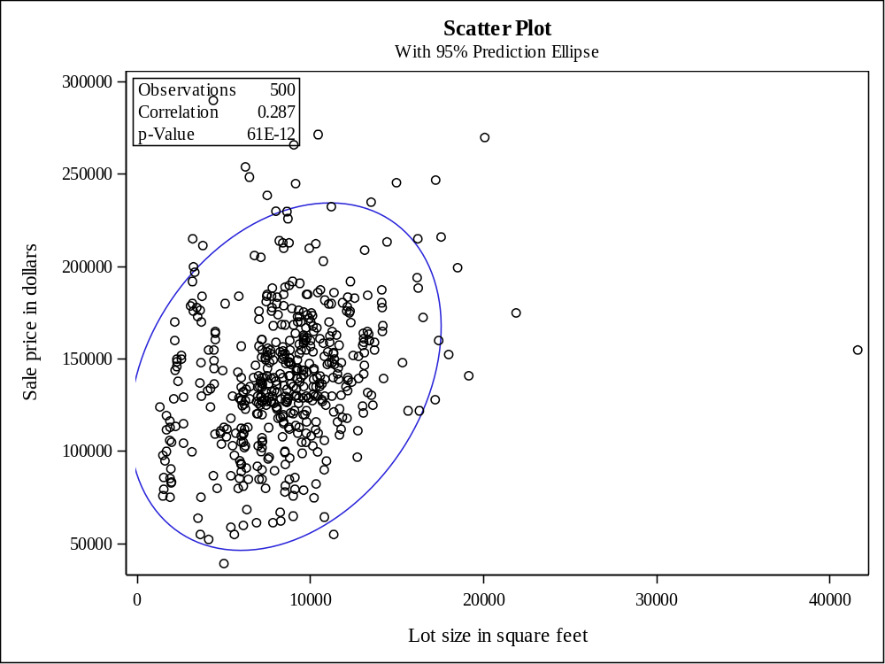

Question 9

Code Snippet
/* The following code uses GLMSELECT statement for multiple linear regression of SalesPrice and the continuous predictor variables in the data set */
proc glmselect data=Project2.team12 plots=all;
STEPWISESL: model SalePrice= Lot_Area Gr_Liv_Area Garage_Area Basement_Area Deck_Porch_Area Age_Sold /
SELECTION=STEPWISE SELECT=SL SLENTRY=0.05;
title 'SL STEPWISE Selection with SalePrice';
run;
quit;

/* The following code uses GLMSELECT statement for linear regression of SalePrice and the most significant continuous predictor variable Age_Sold in the data set */
proc glmselect data=Project2.team12 plots=all;
FORWARDSL: model SalePrice= Age_Sold / SELECTION=FORWARD SELECT=SL SLENTRY=0.05;
title 'SL FORWARD Selection with SalePrice';
run;
quit;

Output
Data Set | PROJECT2.TEAM12
Dependent Variable | SalePrice
Selection Method | Stepwise
Select Criterion | Significance Level
Stop Criterion | Significance Level
Entry Significance Level (SLE) | 0.05
Stay Significance Level (SLS) | 0.15
Effect Hierarchy Enforced | None

Number of Observations Read | 500
Number of Observations Used | 500

Dimensions
Number of Effects | 7
Number of Parameters | 7

Stepwise Selection Summary
Step | Effect  Entered | Effect  Removed | Number  Effects In | F Value | Pr > F
0 | Intercept |  | 1 | 0.00 | 1.0000
1 | Age_Sold |  | 2 | 371.54 | <.0001
2 | Gr_Liv_Area |  | 3 | 233.38 | <.0001
3 | Basement_Area |  | 4 | 158.51 | <.0001
4 | Garage_Area |  | 5 | 56.92 | <.0001
5 | Deck_Porch_Area |  | 6 | 43.10 | <.0001
6 | Lot_Area |  | 7 | 23.12 | <.0001

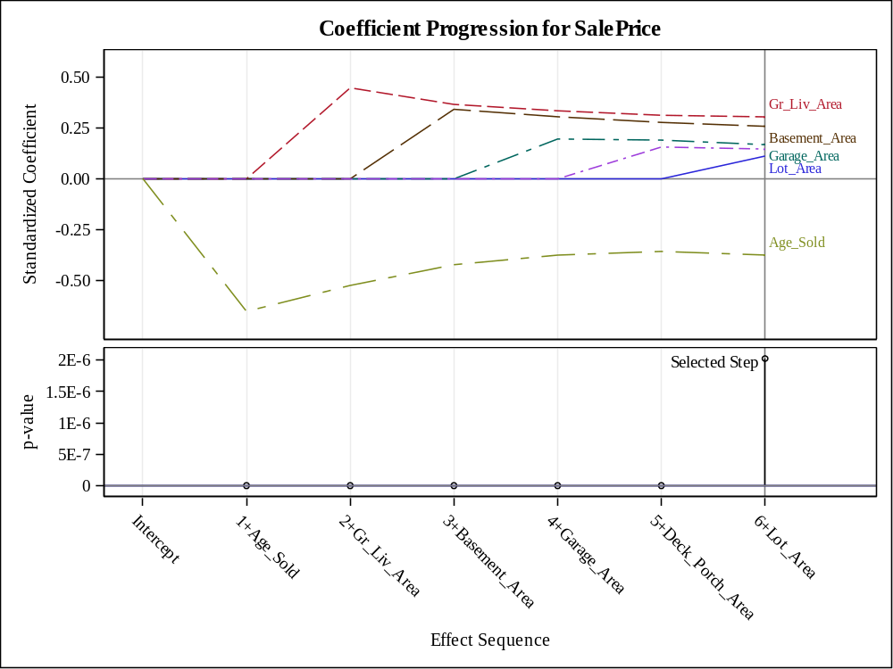
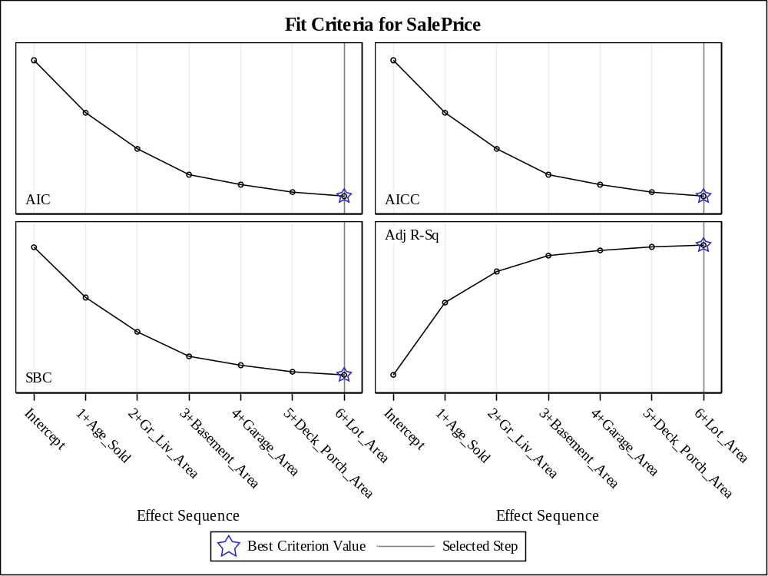
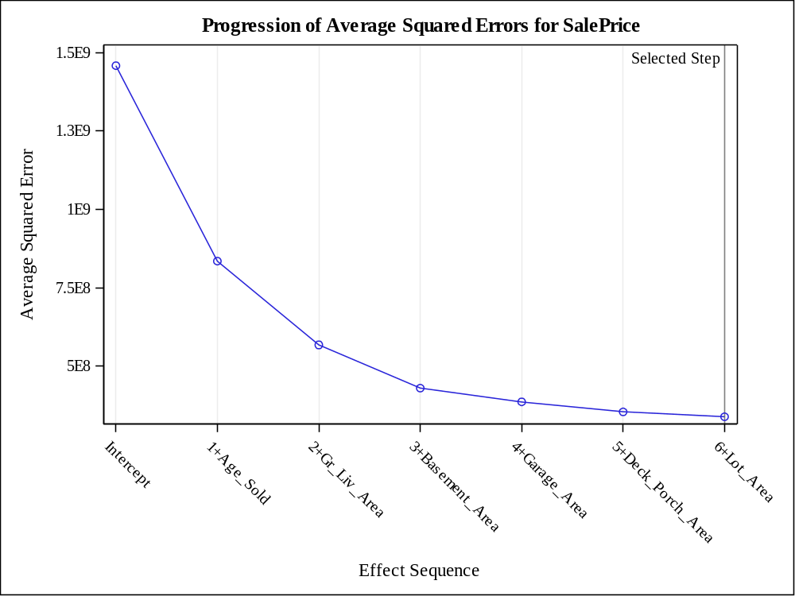
Effects: | Intercept Lot_Area Gr_Liv_Area Garage_Area Basement_Area Deck_Porch_Area Age_Sold

Analysis of Variance
Source | DF | Sum of  Squares | Mean  Square | F Value
Model | 6 | 5.591961E11 | 93199344285 | 270.92
Error | 493 | 1.695956E11 | 344007401
Corrected Total | 499 | 7.287917E11

Parameter Estimates
Parameter | DF | Estimate | Standard  Error | t Value
Intercept | 1 | 50238 | 5476.995173 | 9.17
Lot_Area | 1 | 1.158083 | 0.240862 | 4.81
Gr_Liv_Area | 1 | 50.086858 | 3.958164 | 12.65
Garage_Area | 1 | 34.188997 | 5.060810 | 6.76
Basement_Area | 1 | 30.406970 | 2.979217 | 10.21
Deck_Porch_Area | 1 | 42.426037 | 6.780863 | 6.26
Age_Sold | 1 | -532.072518 | 35.255839 | -15.09

Data Set | PROJECT2.TEAM12
Dependent Variable | SalePrice
Selection Method | Forward
Select Criterion | Significance Level
Stop Criterion | Significance Level
Entry Significance Level (SLE) | 0.05
Effect Hierarchy Enforced | None

Number of Observations Read | 500
Number of Observations Used | 500

Dimensions
Number of Effects | 2
Number of Parameters | 2

Forward Selection Summary
Step | Effect  Entered | Number  Effects In | F Value | Pr > F
0 | Intercept | 1 | 0.00 | 1.0000
1 | Age_Sold | 2 | 371.54 | <.0001

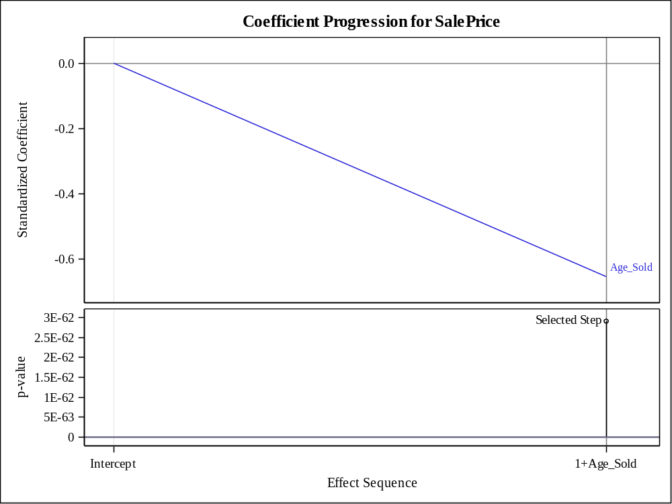
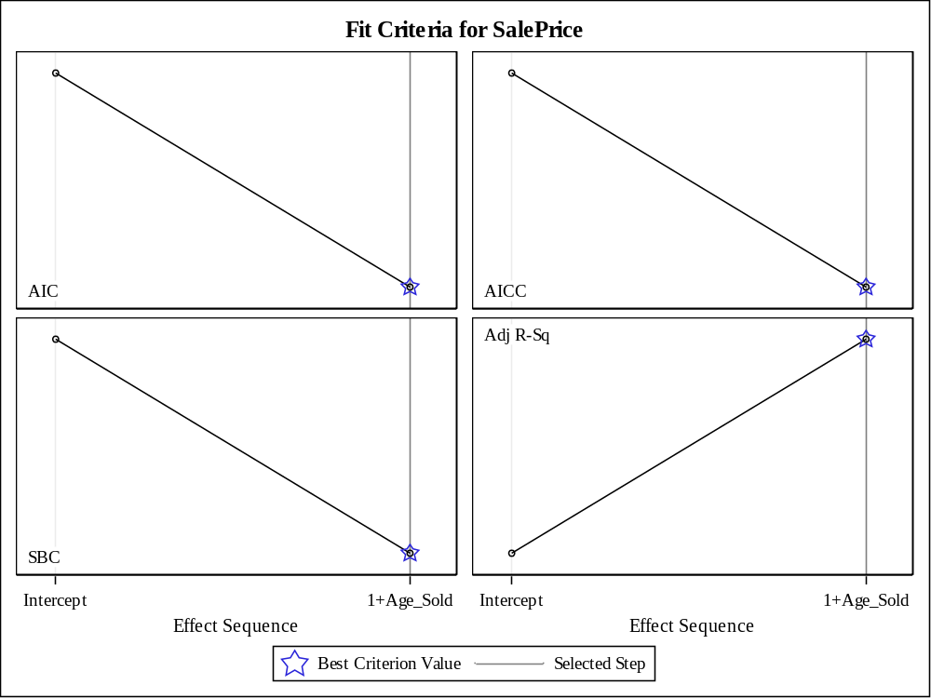
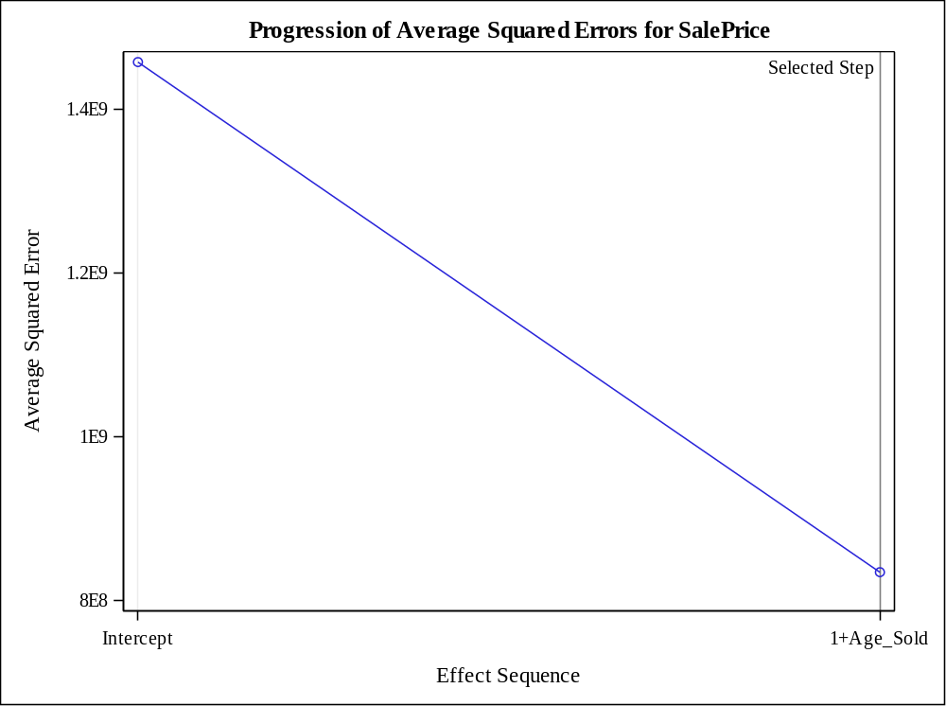
Effects: | Intercept Age_Sold

Analysis of Variance
Source | DF | Sum of  Squares | Mean  Square | F Value
Model | 1 | 3.114011E11 | 3.114011E11 | 371.54
Error | 498 | 4.173906E11 | 838133701
Corrected Total | 499 | 7.287917E11

Root MSE | 28951
Dependent Mean | 140504
R-Square | 0.4273
Adj R-Sq | 0.4261
AIC | 10777
AICC | 10777
SBC | 10284

Parameter Estimates
Parameter | DF | Estimate | Standard  Error | t Value
Intercept | 1 | 181209 | 2477.047432 | 73.16
Age_Sold | 1 | -924.144502 | 47.944240 | -19.28

Question 10

Code Snippet
/* The following code performs a two-way ANOVA of SalePrice with Heating_QC and Season_Sold as predictor variables */

proc glm data=Project2.team12;

class Heating_QC Season_Sold;

model SalePrice=Heating_QC Season_Sold;

means Heating_QC Season_Sold;

title "Two-Way analysis of variance to test for Heating_QC and Season_Sold";

run;

quit;

title;

Output
Class Level Information
Class | Levels | Values
Heating_QC | 4 | Ex Fa Gd TA
Season_Sold | 4 | 1 2 3 4

Number of Observations Read | 500
Number of Observations Used | 500

Source | DF | Sum of Squares | Mean Square | F Value | Pr > F
Model | 6 | 130344004492 | 21724000749 | 17.90 | <.0001
Error | 493 | 598447709975 | 1213889878.2
Corrected Total | 499 | 728791714467

R-Square | Coeff Var | Root MSE | SalePrice Mean
0.178849 | 24.79709 | 34840.92 | 140504.1

Source | DF | Type I SS | Mean Square | F Value | Pr > F
Heating_QC | 3 | 128877532388 | 42959177463 | 35.39 | <.0001
Season_Sold | 3 | 1466472103.9 | 488824034.65 | 0.40 | 0.7511

Source | DF | Type III SS | Mean Square | F Value | Pr > F
Heating_QC | 3 | 128077645450 | 42692548483 | 35.17 | <.0001
Season_Sold | 3 | 1466472103.9 | 488824034.65 | 0.40 | 0.7511

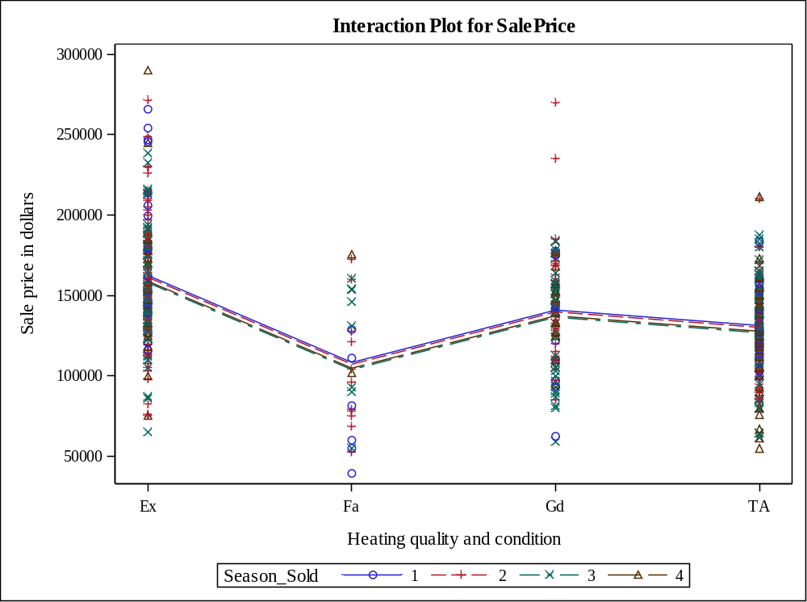
Level of  Heating_QC | N | SalePrice
Level of  Heating_QC | N | Mean | Std Dev
Ex | 182 | 159892.170 | 40119.7287
Fa | 27 | 106298.148 | 40583.5854
Gd | 91 | 138027.363 | 35152.8744
TA | 200 | 128605.625 | 27867.2366

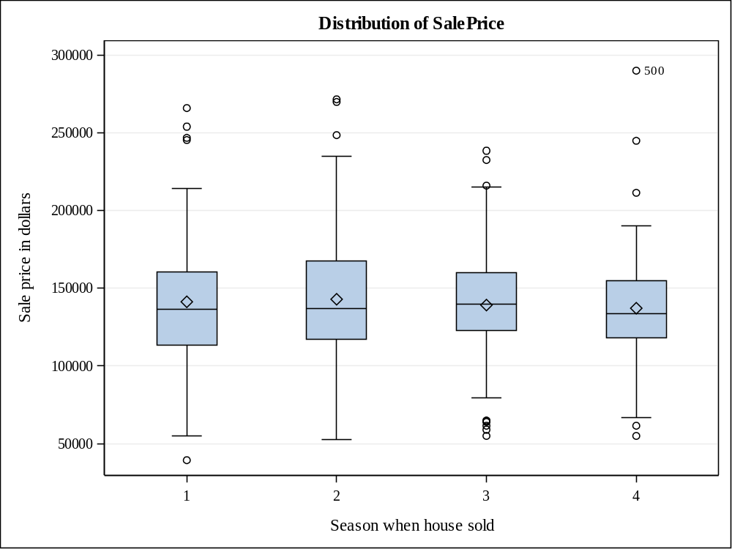
Level of  Season_Sold | N | SalePrice
Level of  Season_Sold | N | Mean | Std Dev
1 | 53 | 141312.415 | 48578.7743
2 | 184 | 142944.201 | 38867.3168
3 | 190 | 139196.311 | 34097.5538
4 | 73 | 137170.548 | 38661.4282

Question 11

Code Snippet
/* The following code performs a two-way ANOVA of SalePrice with Heating_QC and Season_Sold as predictor variables */

proc glm data=Project2.team12;

class Heating_QC Season_Sold;

model SalePrice = Heating_QC Season_Sold Heating_QC*Season_Sold / solution;

store Project2.BlockAnalysis / label='Storing GLM Output';

run;

/* The following code uses PLM statement to store the output to a dataset and adjust p-values and also includes the interaction between the two explanatory variables */

proc plm restore=Project2.BlockAnalysis plots=all;

slice Heating_QC*Season_Sold/ sliceby=Heating_QC adjust=tukey;

effectplot interaction(sliceby= Heating_QC) / clm;

run;

Output

Class Level Information
Class | Levels | Values
Heating_QC | 4 | Ex Fa Gd TA
Season_Sold | 4 | 1 2 3 4

Number of Observations Read | 500
Number of Observations Used | 500

Source | DF | Sum of Squares | Mean Square | F Value | Pr > F
Model | 15 | 153395026268 | 10226335085 | 8.60 | <.0001
Error | 484 | 575396688198 | 1188836132.6
Corrected Total | 499 | 728791714467

R-Square | Coeff Var | Root MSE | SalePrice Mean
0.210479 | 24.53986 | 34479.50 | 140504.1

Source | DF | Type I SS | Mean Square | F Value | Pr > F
Heating_QC | 3 | 128877532388 | 42959177463 | 36.14 | <.0001
Season_Sold | 3 | 1466472103.9 | 488824034.65 | 0.41 | 0.7450
Heating_Q*Season_Sol | 9 | 23051021777 | 2561224641.9 | 2.15 | 0.0240

Source | DF | Type III SS | Mean Square | F Value | Pr > F
Heating_QC | 3 | 99054736542 | 33018245514 | 27.77 | <.0001
Season_Sold | 3 | 2662937046 | 887645682 | 0.75 | 0.5247
Heating_Q*Season_Sol | 9 | 23051021777 | 2561224642 | 2.15 | 0.0240

Parameter | Estimate |  | Standard  Error | t Value | Pr > |t|
Intercept | 124491.8919 | B | 5668.39539 | 21.96 | <.0001
Heating_QC Ex | 34687.0555 | B | 9731.44537 | 3.56 | 0.0004
Heating_QC Fa | 14258.1081 | B | 25030.95629 | 0.57 | 0.5692
Heating_QC Gd | 15864.7748 | B | 10553.97785 | 1.50 | 0.1334
Heating_QC TA | 0.0000 | B | . | . | .
Season_Sold 1 | 7899.3581 | B | 9569.35280 | 0.83 | 0.4095
Season_Sold 2 | 3620.9653 | B | 7008.14381 | 0.52 | 0.6056
Season_Sold 3 | 5634.1355 | B | 6958.17022 | 0.81 | 0.4185
Season_Sold 4 | 0.0000 | B | . | . | .
Heating_Q*Season_Sol Ex 1 | 11063.7998 | B | 14721.18061 | 0.75 | 0.4527
Heating_Q*Season_Sol Ex 2 | -2264.8993 | B | 11293.16390 | -0.20 | 0.8411
Heating_Q*Season_Sol Ex 3 | -10448.6046 | B | 11323.24886 | -0.92 | 0.3566
Heating_Q*Season_Sol Ex 4 | 0.0000 | B | . | . | .
Heating_Q*Season_Sol Fa 1 | -67374.3581 | B | 29734.32250 | -2.27 | 0.0239
Heating_Q*Season_Sol Fa 2 | -39280.0562 | B | 27415.47297 | -1.43 | 0.1526
Heating_Q*Season_Sol Fa 3 | -21521.6355 | B | 28132.52061 | -0.77 | 0.4446
Heating_Q*Season_Sol Fa 4 | 0.0000 | B | . | . | .
Heating_Q*Season_Sol Gd 1 | -25583.1498 | B | 17872.68227 | -1.43 | 0.1530
Heating_Q*Season_Sol Gd 2 | 4583.3324 | B | 13070.12835 | 0.35 | 0.7260
Heating_Q*Season_Sol Gd 3 | -13139.5522 | B | 12545.62785 | -1.05 | 0.2955
Heating_Q*Season_Sol Gd 4 | 0.0000 | B | . | . | .
Heating_Q*Season_Sol TA 1 | 0.0000 | B | . | . | .
Heating_Q*Season_Sol TA 2 | 0.0000 | B | . | . | .
Heating_Q*Season_Sol TA 3 | 0.0000 | B | . | . | .
Heating_Q*Season_Sol TA 4 | 0.0000 | B | . | . | .
The X'X matrix has been found to be singular, and a generalized inverse was used to solve the normal equations. Terms whose estimates are followed by the letter 'B' are not uniquely estimable.

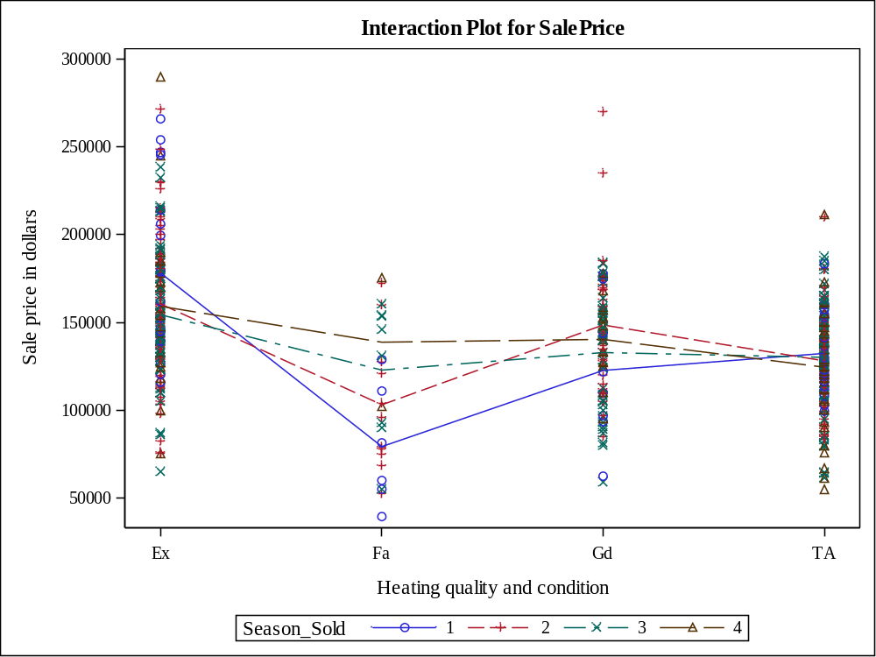

Store Information
Item Store | PROJECT2.BLOCKANALYSIS
Label | PLM: Getting Started
Data Set Created From | PROJECT2.TEAM12
Created By | PROC GLM
Date Created | 28APR16:20:37:15
Response Variable | SalePrice
Class Variables | Heating_QC Season_Sold
Model Effects | Intercept Heating_QC Season_Sold Heating_Q*Season_Sol

Class Level Information
Class | Levels | Values
Heating_QC | 4 | Ex Fa Gd TA
Season_Sold | 4 | 1 2 3 4

F Test for Heating_Q*Season_Sol Least Squares Means Slice
Slice | Num DF | Den DF | F Value | Pr > F
Heating_QC Ex | 3 | 484 | 2.38 | 0.0692

Simple Differences of Heating_Q*Season_Sol Least Squares Means
Adjustment for Multiple Comparisons: Tukey-Kramer
Slice | Season when house sold | Season when house sold | Estimate | Standard Error | DF | t Value | Pr > |t| | Adj P
Heating_QC Ex | 1 | 2 | 17607 | 8855.59 | 484 | 1.99 | 0.0473 | 0.1938
Heating_QC Ex | 1 | 3 | 23778 | 8933.08 | 484 | 2.66 | 0.0080 | 0.0400
Heating_QC Ex | 1 | 4 | 18963 | 11187 | 484 | 1.70 | 0.0907 | 0.3273
Heating_QC Ex | 2 | 3 | 6170.54 | 5751.58 | 484 | 1.07 | 0.2839 | 0.7063
Heating_QC Ex | 2 | 4 | 1356.07 | 8855.59 | 484 | 0.15 | 0.8784 | 0.9987
Heating_QC Ex | 3 | 4 | -4814.47 | 8933.08 | 484 | -0.54 | 0.5902 | 0.9495

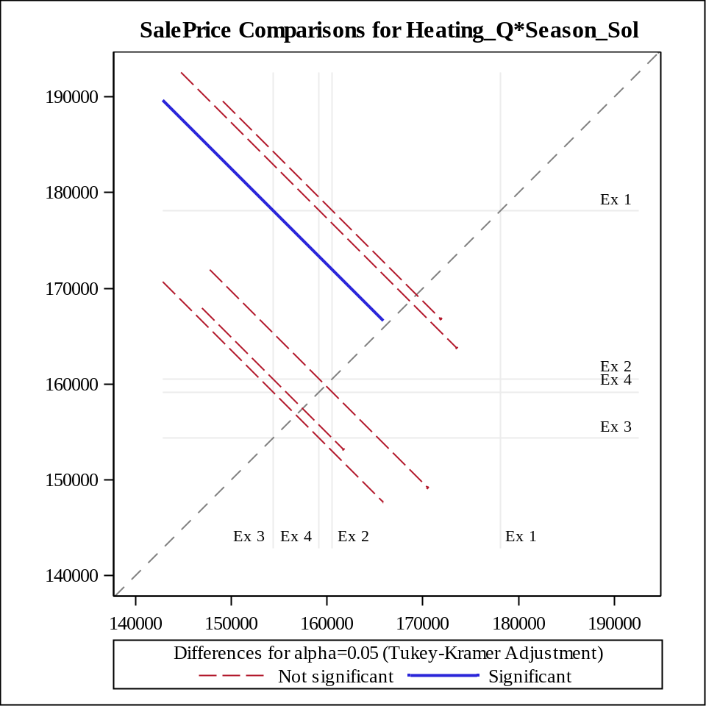
F Test for Heating_Q*Season_Sol Least Squares Means Slice
Slice | Num DF | Den DF | F Value | Pr > F
Heating_QC Fa | 3 | 484 | 2.47 | 0.0615

Simple Differences of Heating_Q*Season_Sol Least Squares Means
Adjustment for Multiple Comparisons: Tukey-Kramer
Slice | Season when house sold | Season when house sold | Estimate | Standard Error | DF | t Value | Pr > |t| | Adj P
Heating_QC Fa | 1 | 2 | -23816 | 17499 | 484 | -1.36 | 0.1742 | 0.5245
Heating_QC Fa | 1 | 3 | -43587 | 18621 | 484 | -2.34 | 0.0196 | 0.0904
Heating_QC Fa | 1 | 4 | -59475 | 28152 | 484 | -2.11 | 0.0351 | 0.1505
Heating_QC Fa | 2 | 3 | -19772 | 16021 | 484 | -1.23 | 0.2178 | 0.6054
Heating_QC Fa | 2 | 4 | -35659 | 26505 | 484 | -1.35 | 0.1791 | 0.5344
Heating_QC Fa | 3 | 4 | -15888 | 27258 | 484 | -0.58 | 0.5603 | 0.9372

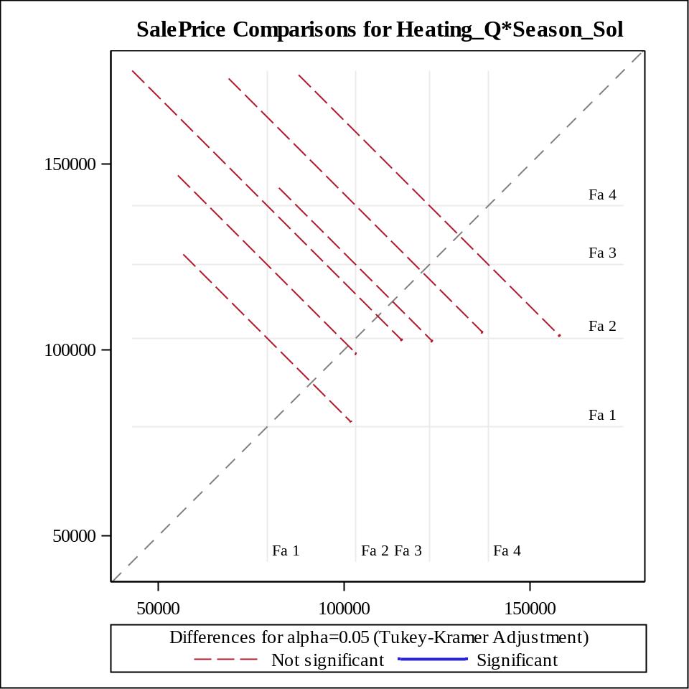
F Test for Heating_Q*Season_Sol Least Squares Means Slice
Slice | Num DF | Den DF | F Value | Pr > F
Heating_QC Gd | 3 | 484 | 1.72 | 0.1613

Simple Differences of Heating_Q*Season_Sol Least Squares Means
Adjustment for Multiple Comparisons: Tukey-Kramer
Slice | Season when house sold | Season when house sold | Estimate | Standard Error | DF | t Value | Pr > |t| | Adj P
Heating_QC Gd | 1 | 2 | -25888 | 13823 | 484 | -1.87 | 0.0617 | 0.2411
Heating_QC Gd | 1 | 3 | -10178 | 13354 | 484 | -0.76 | 0.4463 | 0.8714
Heating_QC Gd | 1 | 4 | -17684 | 15095 | 484 | -1.17 | 0.2420 | 0.6452
Heating_QC Gd | 2 | 3 | 15710 | 8495.84 | 484 | 1.85 | 0.0651 | 0.2517
Heating_QC Gd | 2 | 4 | 8204.30 | 11032 | 484 | 0.74 | 0.4574 | 0.8793
Heating_QC Gd | 3 | 4 | -7505.42 | 10439 | 484 | -0.72 | 0.4725 | 0.8895

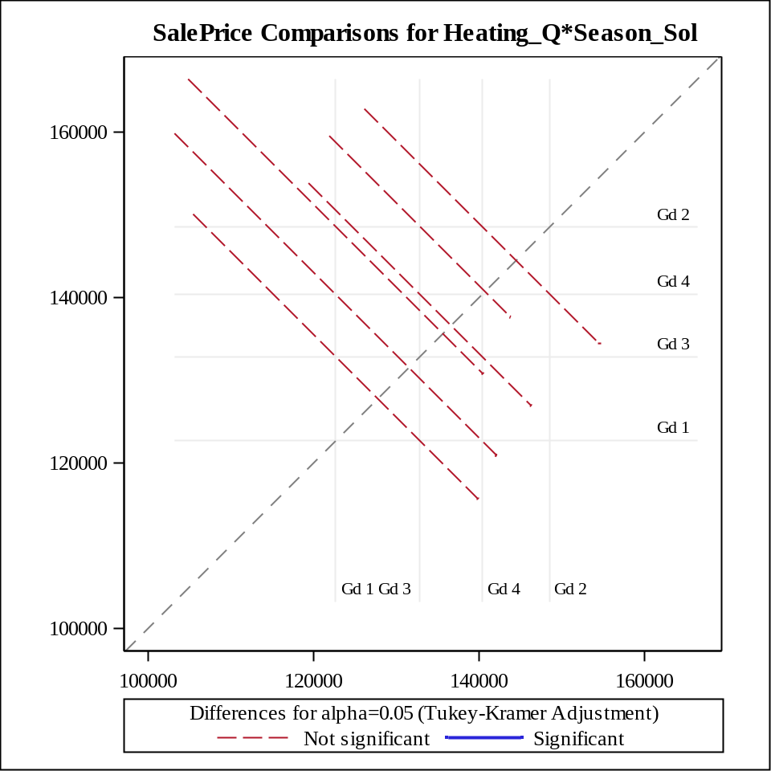
F Test for Heating_Q*Season_Sol Least Squares Means Slice
Slice | Num DF | Den DF | F Value | Pr > F
Heating_QC TA | 3 | 484 | 0.31 | 0.8196

Simple Differences of Heating_Q*Season_Sol Least Squares Means
Adjustment for Multiple Comparisons: Tukey-Kramer
Slice | Season when house sold | Season when house sold | Estimate | Standard Error | DF | t Value | Pr > |t| | Adj P
Heating_QC TA | 1 | 2 | 4278.39 | 8742.15 | 484 | 0.49 | 0.6248 | 0.9614
Heating_QC TA | 1 | 3 | 2265.22 | 8702.14 | 484 | 0.26 | 0.7947 | 0.9938
Heating_QC TA | 1 | 4 | 7899.36 | 9569.35 | 484 | 0.83 | 0.4095 | 0.8424
Heating_QC TA | 2 | 3 | -2013.17 | 5767.91 | 484 | -0.35 | 0.7272 | 0.9854
Heating_QC TA | 2 | 4 | 3620.97 | 7008.14 | 484 | 0.52 | 0.6056 | 0.9551
Heating_QC TA | 3 | 4 | 5634.14 | 6958.17 | 484 | 0.81 | 0.4185 | 0.8499

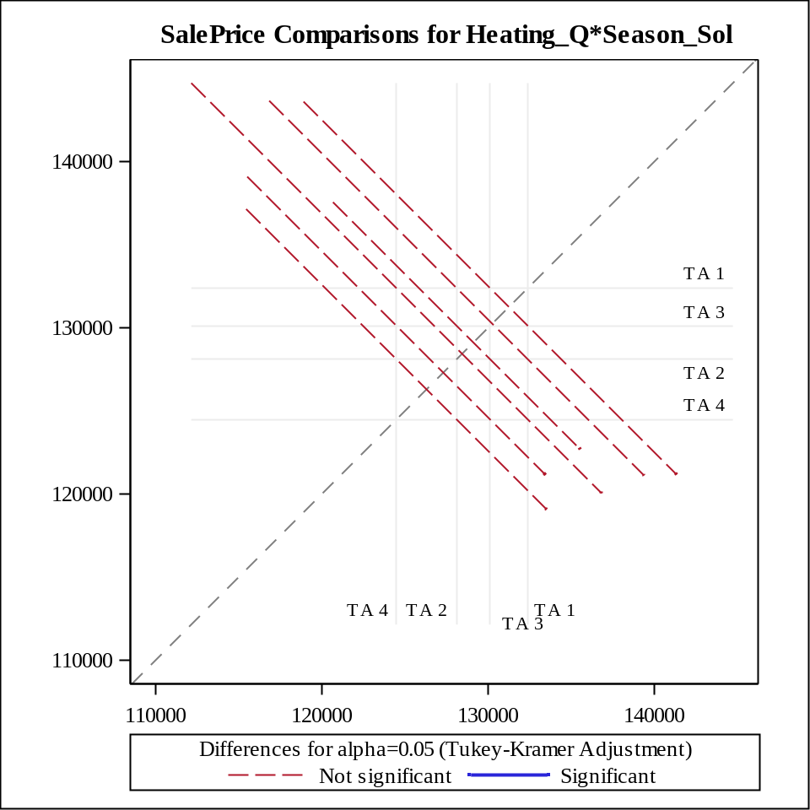
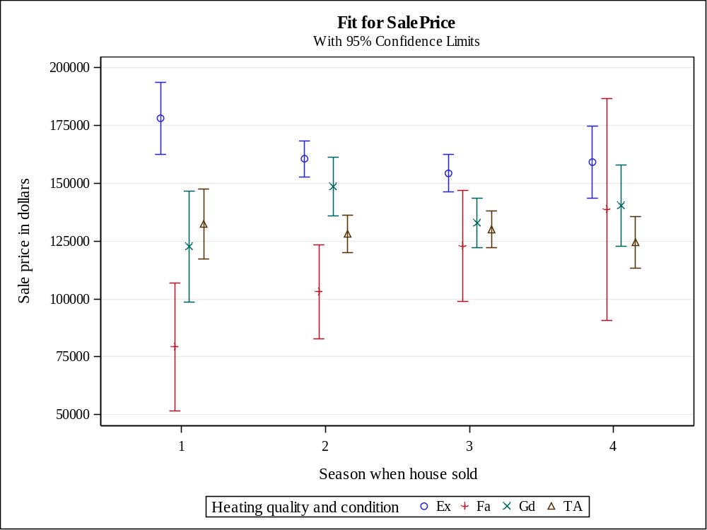

Question 12

Code Snippet

ods graphics on;
/* The following code performs a regression model of SalePrice with Lot_Area and Basement_Area as predictor variables */

PROC REG DATA=Project2.team12 plots=ResidualByPredicted;

MODEL SalePrice=Lot_Area Basement_Area /selection=forward slentry=0.05 ;;

title "Regression Equation to predict SalePrice";

RUN;

QUIT;

title;

ods graphics off;

Output

Number of Observations Read | 500
Number of Observations Used | 500

Forward Selection: Step 1
Variable Basement_Area Entered: R-Square = 0.3785 and C(p) = 19.7150
Analysis of Variance
Source | DF | Sum of  Squares | Mean  Square | F Value | Pr > F
Model | 1 | 2.758325E11 | 2.758325E11 | 303.26 | <.0001
Error | 498 | 4.529592E11 | 909556615
Corrected Total | 499 | 7.287917E11

Variable | Parameter  Estimate | Standard  Error | Type II SS | F Value | Pr > F
Intercept | 74124 | 4043.36196 | 3.056793E11 | 336.08 | <.0001
Basement_Area | 72.73457 | 4.17670 | 2.758325E11 | 303.26 | <.0001

Bounds on condition number: 1, 1

Forward Selection: Step 2
Variable Lot_Area Entered: R-Square = 0.4010 and C(p) = 3.0000

Analysis of Variance
Source | DF | Sum of  Squares | Mean  Square | F Value | Pr > F
Model | 2 | 2.922702E11 | 1.461351E11 | 166.38 | <.0001
Error | 497 | 4.365215E11 | 878312927
Corrected Total | 499 | 7.287917E11

Variable | Parameter  Estimate | Standard  Error | Type II SS | F Value | Pr > F
Intercept | 64145 | 4594.38507 | 1.712066E11 | 194.93 | <.0001
Lot_Area | 1.61297 | 0.37285 | 16437669800 | 18.72 | <.0001
Basement_Area | 68.55875 | 4.21631 | 2.322251E11 | 264.40 | <.0001

Summary of Forward Selection
Step | Variable  Entered | Label | Number  Vars In | Partial  R-Square | Model  R-Square | C(p) | F Value | Pr > F
1 | Basement_Area | Basement area in square feet | 1 | 0.3785 | 0.3785 | 19.7150 | 303.26 | <.0001
2 | Lot_Area | Lot size in square feet | 2 | 0.0226 | 0.4010 | 3.0000 | 18.72 | <.0001

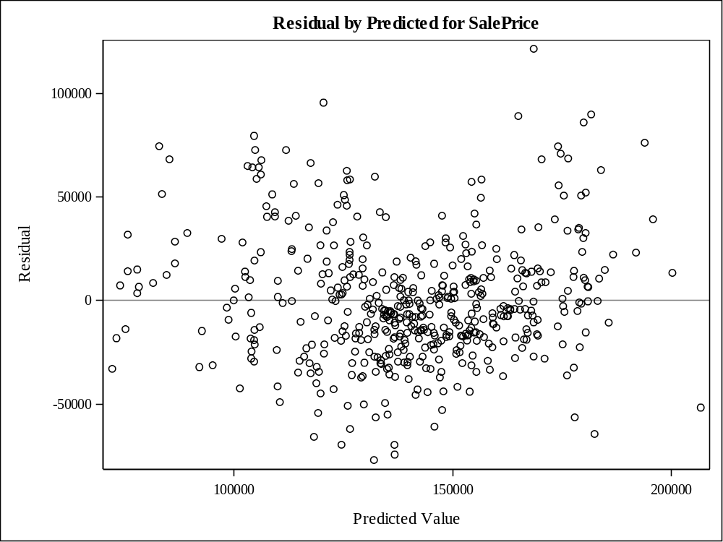
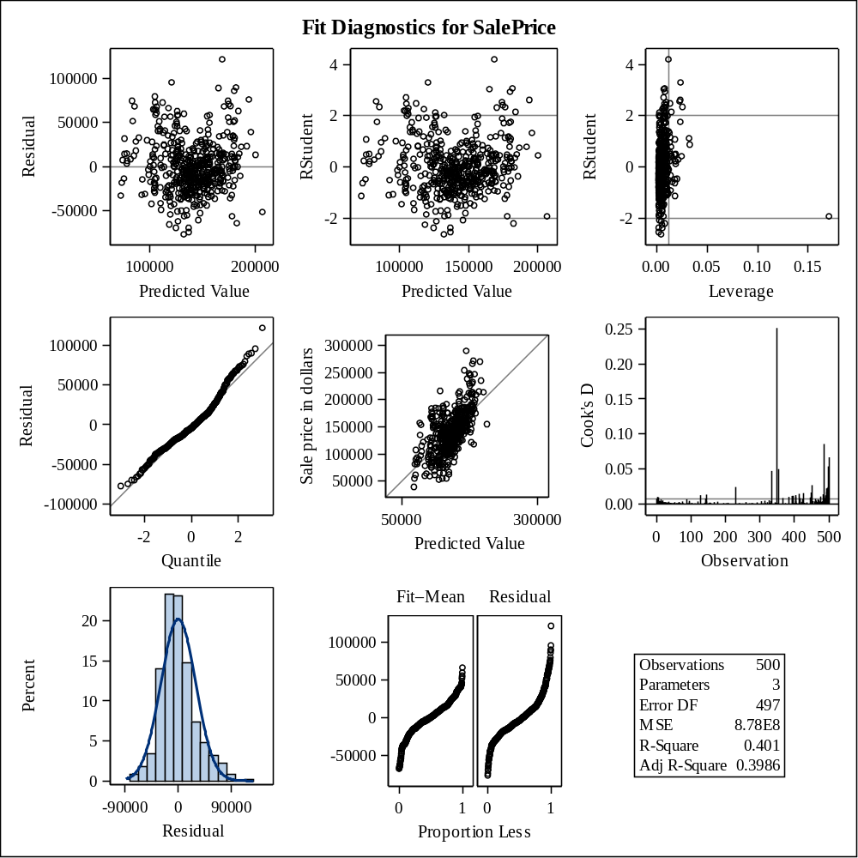

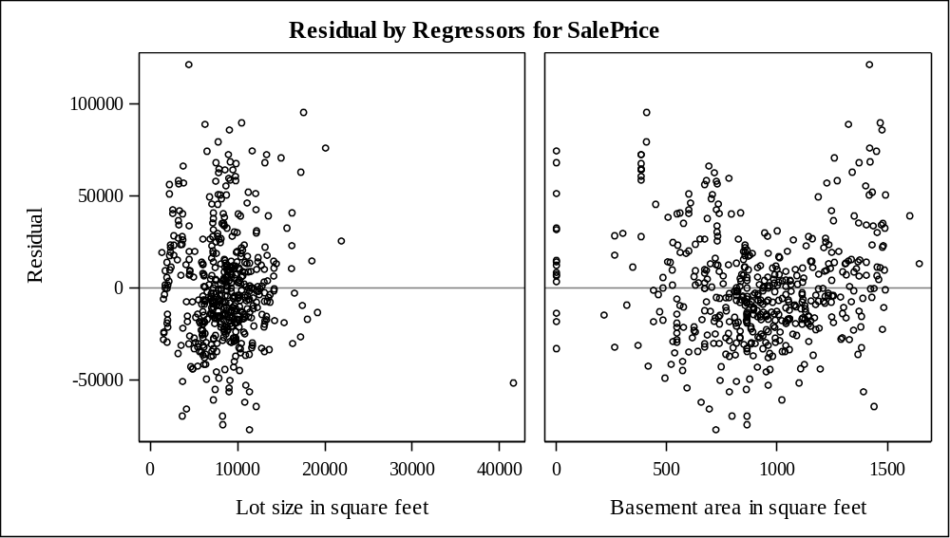

SAS file
The SAS file is attached for reference.



References
This section cites the functions and definitions that are used in the report
- https://support.sas.com

